# DevOps

# This course divided in to 8 parts:

1. 🡪Basics of linux

🡪server Management in linux

🡪vagrant

🡪basic of networking

* Vprofile project intro & setup on vm’s

1. 🡪cloud computing intro on aws

* IAM, EC2 Instance, EBS volume, ELB, S3 Cloudwatch, RDS, Autoscaling, Route53
* Vprofile project setup on aws cloud

1. Continuous integration by using

🡪GIT , MAVEN, JENKINS, NEXUS, SonarQube.

* Continuous integration/Delivery
* CICD Pipelines
* Jenkins administration
* Pipeline as a code

1. Scripting

* Bash scripting : veriables, conditions, loops etc. Automating day-to-day admin task
* Python programming basics: vars, datatypes, conditions, loops, function, modules etc. pythons for automating OS tasks.

1. Ansible

* Ansible intro
* Ad Hoc commands
* Modules
* YAML intro
* Playbooks

Var, conditions, loops, handlers.

Templates

🡪Variable deep dive & Roles

* Ansible for AWS

1. AWS part 2

🡪VPC in depth

🡪log management and custom metrics

* Cloudwatch
* AWS CLI & S3 CLI
* Beanstalk & RDS
* Vprofile on BeanStalk
* Code commit, code build & code
* Pipeline

1. Docker intro-🡪 part 1

* Understanding and implementing containers
* Volumes, network, logs etc
* Building images for Vprofile project
* Docker compose to run vprofile multi containers

Kubernetes intro 🡪 part 2

* Kubernetes setup for production ENV
* Kubernetes objects Pods, Services, Controllers, Deployment Replication, Autoscaling, Resource quotas, Secrets, configmap, namespace.

1. Terraform

* Cloud automation with terraform, cloudformation.

## What is devOps?

Before go to the devops, we need to understand the 🡪(why we need to devops engineer)

Example:

A costumer (ama)wants to expand the business in online so, costumer reaches the software consulting from and she explain the idea. so

Director of dev and ops team: explains the development and operations and service of software.

Development:

At first, they follow the **waterfall method** but it takes lot of time to completed the project even the months and request a have requirement for project at start. So, they dev the work with **agile mythology.** in agile feature divided to some iterations. every new iteration developer will work on new features so that continuous feature will add to the project as per the costumer required and update the exiting feature according to the need.

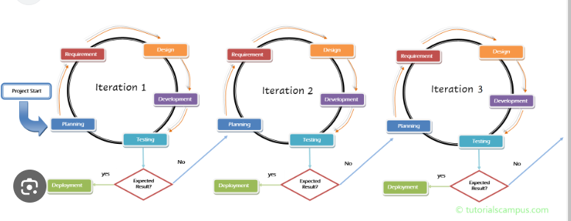

Software development process:

🡪 Requirement gathering (product feature, user, usage, user requirement, market site)

🡪 planning (it determines the cost, resource & Risk associated with it)

🡪 design (architects will design the software based on requirements🡪architect will product the design document which will the roadmaps for the developers)

🡪implementation (developer phase, developer will developer the code based on the design documents)

🡪testing & Quality Assurance (this phase software is tested to find any bugs in coded)

🡪Deployment (software deployed in production deployment so that user can use the feature/product)

* maintenance: it is balance b/w regular changes and uptime

SDLC: software development lifecycle

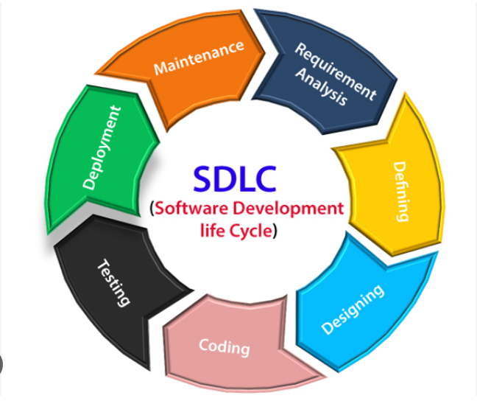

Models in SDLC:

* Waterfall
* Agile
* Spiral
* Big bang

Etc

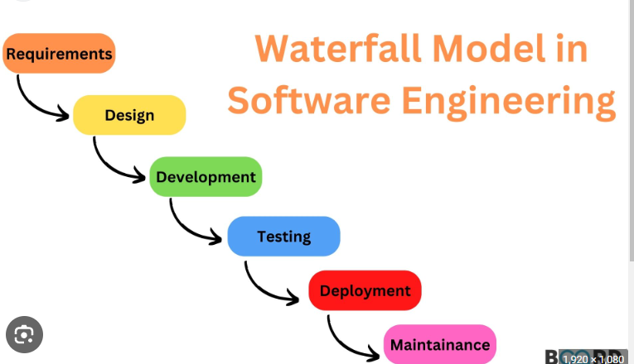

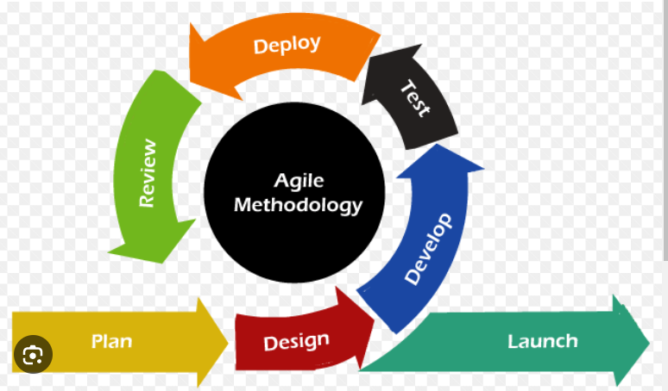

OPEARTION TEAM:

Follows the ITIL for stable environment.

But due to the agile model follow by dev.

operation team is get the

* regular deployment request.
* No clear instruction
* Maintance the uptime at all time

But they getting error due to the not clear instruction. this leads to delay of project. this result loss of costumer (loss of business).

Director of dev&ops teams as appointed the **devops consult** to sort the issue and speed up the process by automate the thinks.

Devops consult reach the dev & ops team. And sort the think by explain the process each team so they will understand the flow the work. Ask then to automate the process like

Automating:

* Code build
* Code testing
* Software testing
* Infra changes
* Deployments
* Everything come across the way

ITIL: “Information Technology Infrastructure Library”

The acronym was first used in the 1980s by the British government's Central Computer and Telecommunications Agency (**CCTA**) when it documented dozens **of best practices in IT service management and printed them for distribution.**

ITIL is a set of best practices that help organizations align IT services with business strategy. The ITIL lifecycle consists of five stages: Service Strategy, Service Design, Service Transition, Service Operation, Continual Service Improvement.

Continual Improvement is a key component of the ITIL Service Value System (SVS). It is a recurring activity that ensures performance continually meets stakeholder expectations.

**ITIL has four levels of certification:**

* Foundation
* MP (Managing Professional)
* SL (Strategic Leader)
* Master

[**https://www.ibm.com/topics/it-infrastructure-library#:~:text=ITIL%20stands%20for%20Information%20Technology,and%20printed%20them%20for%20distribution**](https://www.ibm.com/topics/it-infrastructure-library#:~:text=ITIL%20stands%20for%20Information%20Technology,and%20printed%20them%20for%20distribution)**.**

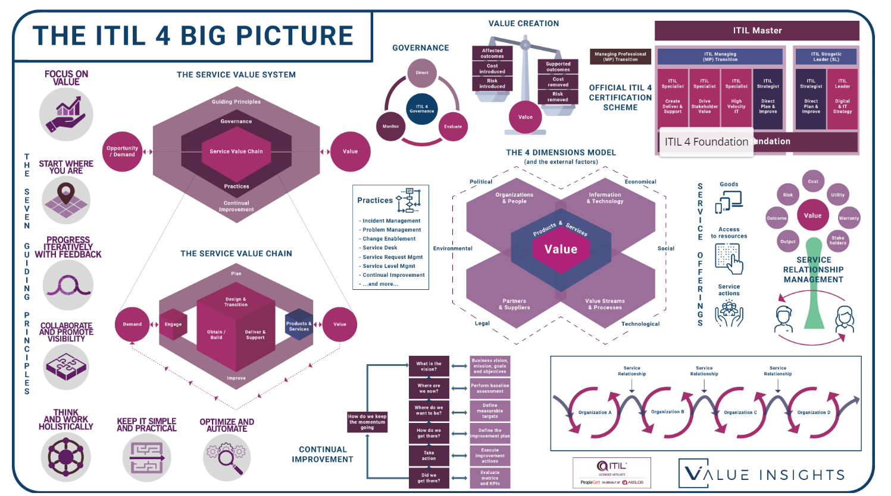

Devops life cycle:

Code🡪code build🡪code test 🡪 code analysis 🡪 delivery 🡪 DB/Security DB changes🡪 software testing🡪deploy to prod 🡪go live 🡪 user approval🡪 monitoring

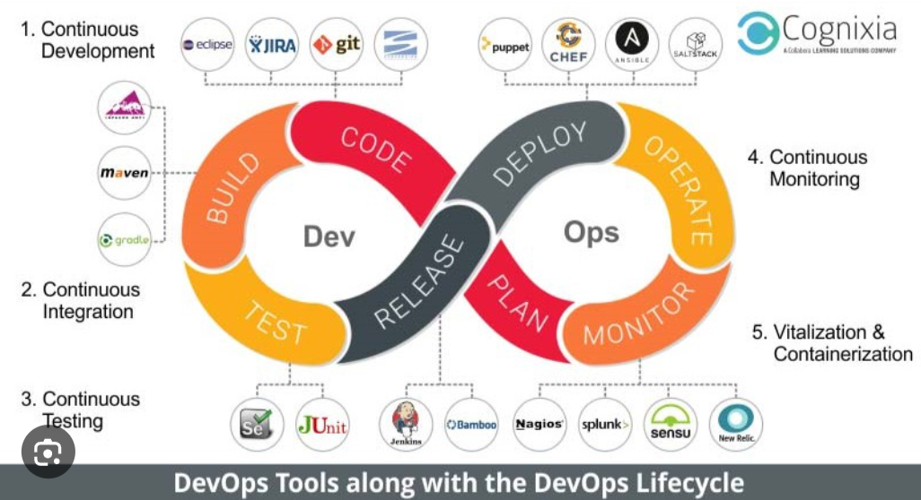

Continuous integration:

Dev(**code** to create a software) 🡪centralized repository(like GitHub)🡪build sever(build, test & evaluated🡪 which generate the software, call artifact) 🡪 centralized repository( to store the artifects(war/jar🡪java, DLL/EXE/MSI🡪windows, zip/TAR ball tar.gz )🡪deploy the artifact to the server(after deploying this artifact on the sever. Testers do testing once approve) 🡪 production servers.

but there is problem in it, when developer code continuous for 3 weeks and committed to repository in several time in a day. So, it not integrated well, so when building the code in build servers it got lot of error (result a lot of reworks). To avoid this by automate the work by every commit done by the developer the code need to build it , if it got error notification will sent to dev.

**To automate the continuous build of code by every commit done developers is called continuous integration**.

Code🡪fetch🡪build🡪test🡪notify🡪feedback ---------------- >**it is the cycle**

**IDE** tools 🡪 integrated with **version control system** 🡪**build tools** 🡪**software repository**(to store artifacts) 🡪 **CI TOOLS**

**IDE –** ECLIPSE, VISUAL STIDIO, ATOM, PYCHARM etc

**VCS**- VERSION CONTROL SYSTEM – git, SVN, TFS, PREFORCE etc

**Build tools –** maven, ant, gradle, msbuild, visual build, make, grunt etc

**Software repository -** Sonatype Nexus, jfrog artifactory, archiva, cloudsmith package, grunt

**CI TOOLS –** Jenkins, circleci, teamcity, bamboo ci, cruise control.

# Continuous delivery

Continuous delivery is mainly focus on (deployment process🡪testing 🡪production)

* Ops team will get regular requests to deploy the artifacts generated from CI process on servers but ops team as a lot human interventions so process getting delay to avoid this automate the process

Deployment means not only shipping the artifacts to the server and also

* Server provisioning
* Dependencies
* Conf changes
* Network
* Artifact deploy etc

Automation tools:

Ansible, puppet, chef for system/server

Terraform, Cformation for cloud infrastructure automation

Jenkins, octopus deploy for CICD Automation

Helm charts

Code deploy etc

Dev team🡪ops team🡪QA team all are automated and sync to each process

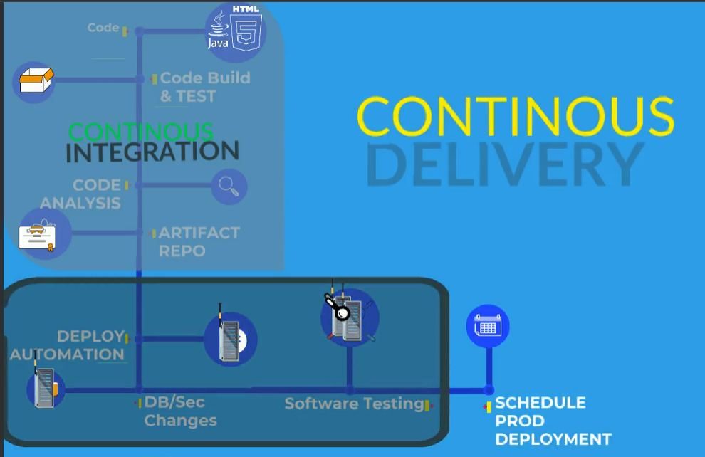

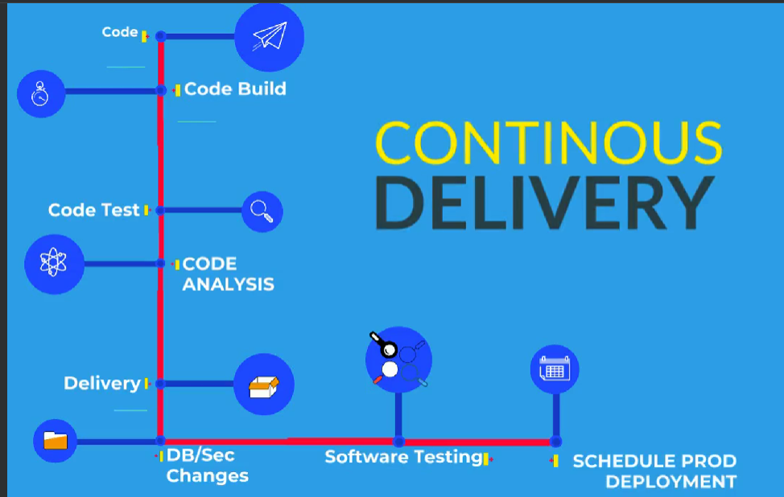

Prerequisites:

Tools:

* Oracle virtual box, AWS CLI
* Git bash
* Vagrant
* Chocolatey/brew 🡪 I had not use this ------------------------------------------------ https://community.chocolatey.org/packages
* JDK8
* MAVEN, visual studio, sublime test editor, intellj

Sign-in / sign up

* GitHub
* Domain purchase(go daddy)
* Docker hub
* Sonarcloud

Aws

* Free tier account
* IAM and MFA
* Billing alarm
* Certificate setup

# Ubuntu system prerequisites

**Install Vagrant**

$ curl -O <https://releases.hashicorp.com/vagrant/2.2.9/vagrant_2.2.9_x86_64.deb>

$ sudo apt install ./vagrant_2.2.9_x86_64.deb

**Install Git**

$ apt install git

**Install jdk8**

$ sudo apt-get install openjdk-8-jd

**Install Maven**

$ sudo apt-get install maven

**Install awscli**

$ sudo apt-get install awscli

**Install Intellij community**

$ sudo snap install intellij-idea-community --classic

**Install Sublime Text**

$ sudo apt update

$ sudo apt install dirmngr gnupg apt-transport-https ca-certificates software-properties-common

$ curl -fsSL https://download.sublimetext.com/sublimehq-pub.gpg | sudo apt-key add -

$ sudo add-apt-repository "deb https://download.sublimetext.com/ apt/stable/"

$ sudo apt install sublime-text

For sign up I didn’t take note…I can do it my own

AWS SETUP

Search for **aws free tiar** 🡪 [https://aws.amazon.com/free/?all-free-tier.sort-by=item.additionalFields.SortRank&all-free-tier.sort-order=asc&awsf.Free%20Tier%20Types=*all&awsf.Free%20Tier%20Categories=*all](https://aws.amazon.com/free/?all-free-tier.sort-by=item.additionalFields.SortRank&all-free-tier.sort-order=asc&awsf.Free%20Tier%20Types=*all&awsf.Free%20Tier%20Categories=*all)

Create a free tiar account🡪login 🡪 check if you account is active or not (EC2 all service is available or not(error like verify you phone or card) )

if need we can check with support center

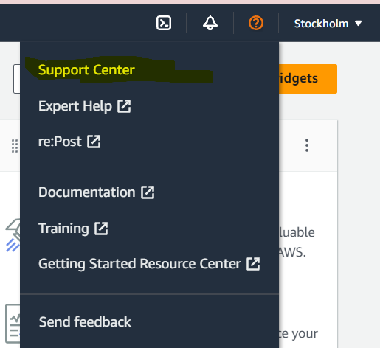

MFA🡪Add MFA🡪Assign MFA device :- use your phone authenticator app to scan QR

* For root & IAM create MFA

But we login to the AWS Account, it is root user Account we do not recommend to use root user account 🡪create admin user using IAM

IAM🡪 USER🡪 add user 🡪 name :ITADMIN🡪keep auto-generated password, check box for ask the new password for next login🡪 attached the policies directly 🡪select 🡪 administatorAccess🡪Create user

For MFA

Click-on itadmin🡪security credentials🡪asign MFA device🡪give the name🡪 authenticator app to scan QR

# Billing alarm

User(Purandhar)🡪billing dashboard🡪billing preferences🡪invoice delivery perferences(edit and click on update) 🡪alert preferences click on check box and update (give the mail)

# Cloud watch

CloudWatch 🡪All alarm 🡪create alarm🡪select metric🡪 come down, we can see **billing** 🡪click and select total estimated charge on that🡪select threshold value as 5 dollars 🡪next🡪 select an SNS 🡪select the exiting sns topic 🡪 give mail id in send notification🡪 add the name & description like

“AWSBillingAlert ”. 🡪 create Alarm.

We need to confirm the Gmail account by click on link in Gmail and get confirm

If your bill reach/cross 5 dollars the in the alarm (in the of OK it will appear as alarm) and we will receive the mail for alarm

# ACM – AWS Certificate Management

AWS Certificate Manager🡪 Certificates 🡪 Request Certificate🡪request public Certificate🡪next🡪give domain name *. purandhar.in 🡪add the tag name= Purandhar.in

ACM🡪 Certificate🡪 click on Certificate id🡪domain : CNAME name, CNAME value (we need to add this record to the domain register (GoDaddy)

Godaddy🡪my product🡪 Purandhar.in(domain)🡪manage domain🡪DNS🡪new records🡪(CNAME , past the CNAME name(just name don’t keep .hkhinfo.xyz at last) , past the CNAME value(keep only the value(keep up to aws.). Remove the domain at end present).

* It might take 40 hour also

We can name by using Alias to avoid the number in IAM user

We change the credential of IAM (IAM 🡪user🡪itadmin(user name)🡪security credential🡪manage 🡪give autogenerated password checkmark on new password on next login)

# virtualization

back early day, we using the computer as clints(linux) connect to ethernet and use it other computer but takes a lot space, it will be very expensive . 🡪 after that virtualization(1960’s by IBM) then we can use the virtualization on top of our machine to create many VM, result to reduce the cost & rubust time-sharing solution .

**OS = OS (clint connected to user machine) 🡪 Virtualization 🡪 containization (container) 🡪 serverless**.

* Refer the vm setup pdf (for more info)

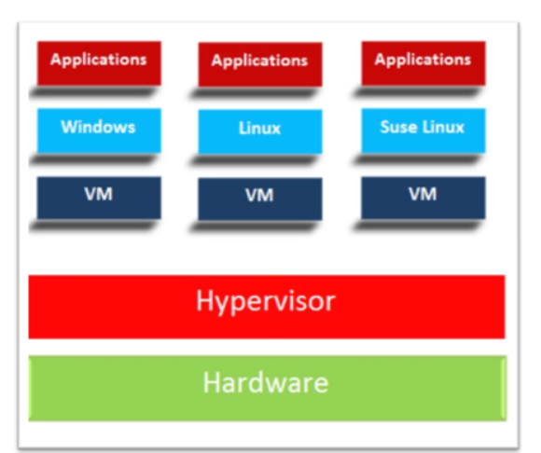

Host OS 🡪This is os system of physical machine(physical -os)

Gest OS 🡪 This is the operating system(OS) of virtual machine.

VM 🡪 virtual machine.

Snapshot 🡪 way of taking backup’s in virtual machine.

Hypervisor 🡪 is tool / software that let us do or create a virtual machine( Two type of hypervisor are they, we are using type to of learning )

Type 1

○ Bare Metal

○ Runs as a Base OS

○ Production

○ E:g VMware esxi, Xen Hypervisor

Type 2

○ Runs a software

○ Learn & test

○ E:g Oracle VirtualBox, VMware server

Stay up to date, we don’t use virtualization now in real time, but make a idea

<https://visualpath.in/devopstutorials/devops> refer this link for more info

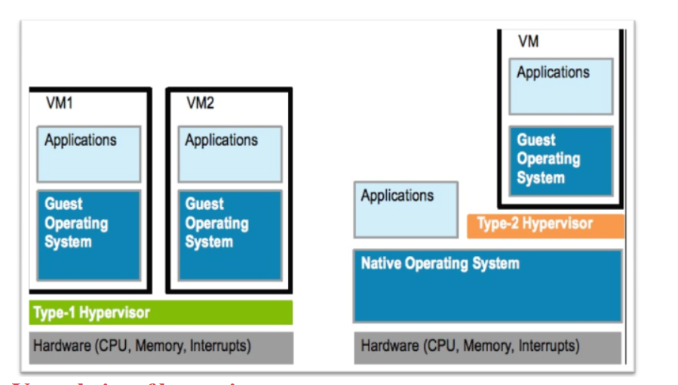

# VTx

# **Enable Virtualization in BIOS -- search in google /see the image(if required)**

● VTx

● Secure virtual machine

● Virtualization

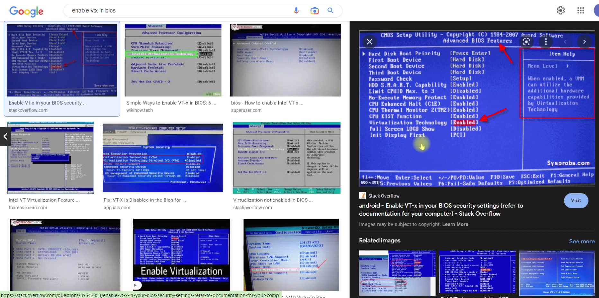

Disable other windows virtualization (search bar 🡪 turn windows feature ON / OFF)

● Microsoft Hyperv

● Windows Hypervisor platform

● Windows Subsystem for linux

● Docker Desktop

● Virtual Machine Platform

🡪restart the mahine

# Create a VM manually

Requirements:

Oracle VM VirtualBox – hypervisor

ISO File -- centos &ubuntu

Login tool -- git bash & putty

Open oracle virtual box 🡪new 🡪 config as follow screenshot

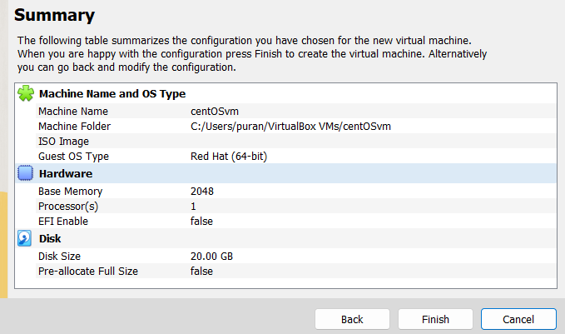

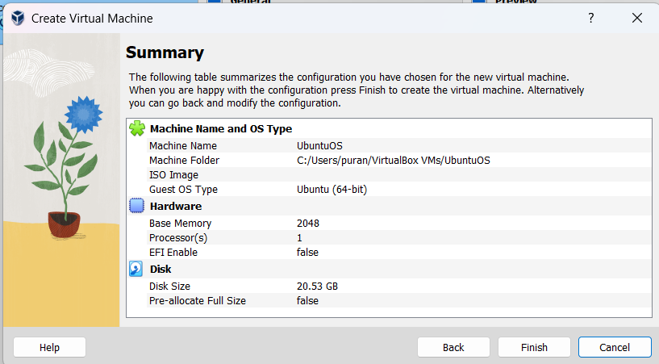

We had two VM but they is not OS on it, To install OS need ISO file

( search in google alamalinix 9 iso <https://repo.almalinux.org/almalinux/9/isos/x86_64/> )

Download boot.iso extension file

**Attach the ISO file in VM :** CENTOSVM 🡪setting🡪storage🡪disk🡪choose disk dropdown and attach the disk🡪checkmark on live cd/dvd

CENTOSVM 🡪setting🡪network🡪adapter 2🡪enable network adapter 🡪dropdown select bridge adapter🡪select the appropriate (if you connect wife (select wife), if you connect on LAN select LAN)

Cmd Ipconfig (it show’s network interface(that computer connect to network like wifi/LAN etc assign to ip’s)

All setting are done select vm 🡪start🡪select the disk (need to do two time)🡪check for bridge adapter🡪set the root password🡪click on begging installation.

NOTE : click on right control to release your cursur

“” after the installation don’t reboot it, stop/shut down the VM we need to remove the disk(almalinux 9 iso file because once reboot again it will install “

One centos VM login 🡪 see the ip address of centos (ip addr show) take the ip address of bridge adapter

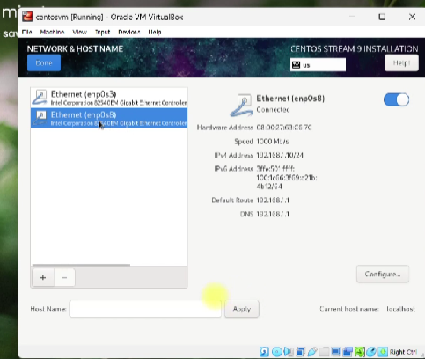

Now we can ssh centos to in our machine

Git bash🡪 ssh user@ipaddrss

Eg : ssh centosuser@192.168.1.10 🡪give the password then you can login

Similar to centOS 🡪 For ubuntu ubuntu 22 server iso(jammy jally image🡪server image

(add the disk, give the bridge adapter, install it, before reboot remove the disk 🡪start 🡪get the ip address 🡪 ssh to local machine)

Note : set openshh server (by using space bar) 🡪 if you do not select you are not able ssh

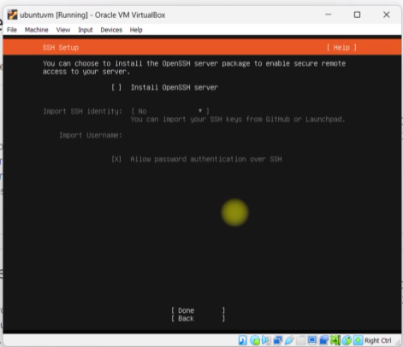

# Vagrant

* Vagrant Manages/ Automates VM Lifecycle
* Problem of Vm management (manual)

OS Installations

● Time Consuming

● Manual setup

● Tough Replication for Multi VM

● Documentations for Multi VM

## Vagrant for VM’S

* NO OS Installations
* VM Setup through Images(vagrant boxes)
* Images/Boxes available in Vagrant cloud
* Manage VM’s with a file (Vagrantfile)
* VM changes automatic through Vagrantfile
* Vagrant commands to manage VM’s
* Provisioning VM/Executing commands & scripts
* Etc…

agrant is a tool for managing virtual machine (VM) environments. It allows you to create, configure, and manage VMs for development and testing purposes. Here are some common Vagrant commands:

1. **vagrant init [box_name]:** Initializes a new Vagrant environment in the current directory with a Vagrantfile, which is a configuration file for your VM.
2. **vagrant up:** Starts and provisions the VM based on the configuration in the Vagrantfile.
3. **vagrant halt:** Stops the running VM.
4. **vagrant reload:** Halts and then restarts the VM. Useful when you make changes to the Vagrantfile.
5. **vagrant suspend:** Saves the current state of the VM and stops it. You can resume it later using **vagrant resume**.
6. **vagrant resume:** Resumes a suspended VM.
7. **vagrant status:** Displays the status of the VM (running, stopped, etc.).
8. **vagrant ssh:** Connects to the VM using SSH.
9. **vagrant ssh-config:** Displays the SSH configuration for the VM.
10. **vagrant destroy:** Stops and deletes the VM. Use with caution, as it will delete all data associated with the VM.
11. **vagrant global-status:** Lists information about all Vagrant environments on the host machine.
12. **vagrant plugin install [plugin_name]:** Installs a Vagrant plugin.
13. **vagrant plugin list:** Lists installed Vagrant plugins.
14. **vagrant plugin uninstall [plugin_name]:** Uninstalls a Vagrant plugin.
15. **vagrant box add [box_name] [box_url]:** Adds a new box (VM image) to Vagrant. You can specify a URL or a local file path.
16. **vagrant box list:** Lists all available Vagrant boxes on your system.
17. **vagrant box remove [box_name]:** Removes a box from your system.
18. **vagrant box update:** Checks for updates to installed boxes.
19. **vagrant provision:** Re-runs the provisioning script defined in the Vagrantfile.
20. **vagrant ssh-config [machine_name]:** Displays the SSH configuration for a specific machine within a multi-machine Vagrant environment.

**Vagrant global-status --prune**

These are some of the most commonly used Vagrant commands. You can run these commands in your terminal while inside the directory where your Vagrant environment is set up (where the Vagrantfile is located). Additionally, you can use **vagrant --help** to get a list of all available commands and their descriptions.

Top of Form

Regenerate

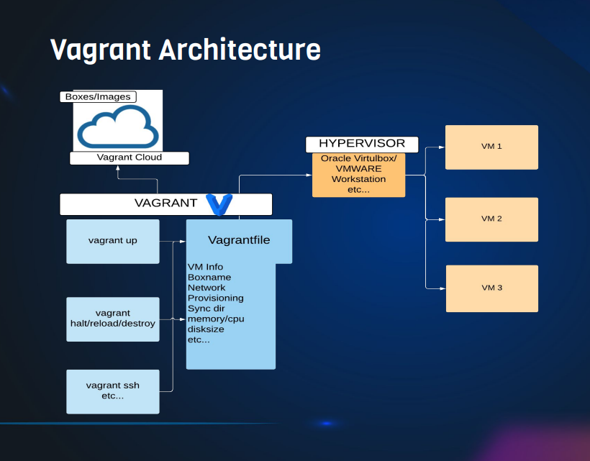

Always make the proper folders

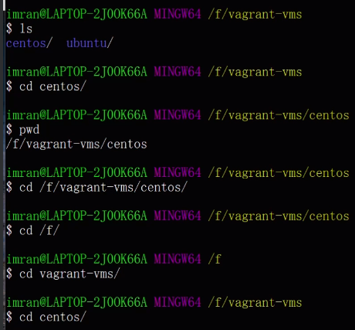

Vagrant Setup

* VT (Virtualization Technology) Enabled in BIOS
* Vagrant tool
* Hypervisor like Oracle Virtualbox
* CLI (Command Line Interface) like GIT Bash, Cygwin, CMD prompt etc…

HAND-ON:

Create a folder in you drive “ Vagrant” and other linux-OS

Eg : c/user/puran/Vagrant-VMS/CentOSVM

Go to 🡪vagrant cloud(https://app.vagrantup.com/boxes/search) 🡪select the box(see if it support virtual box )🡪 copy the name(centos/7)

🡪Vagrant init centos/7

* Vagrant up

If you got any error like “error : next intializesecuitycontext” or vbox hardening

This is because of anti-virus need to disable it , if you are VPN, or carparate network get out of network

# LINUX

Linus Benedict Torvald (gave & open source unix like kernel – Linux, created the git etc)

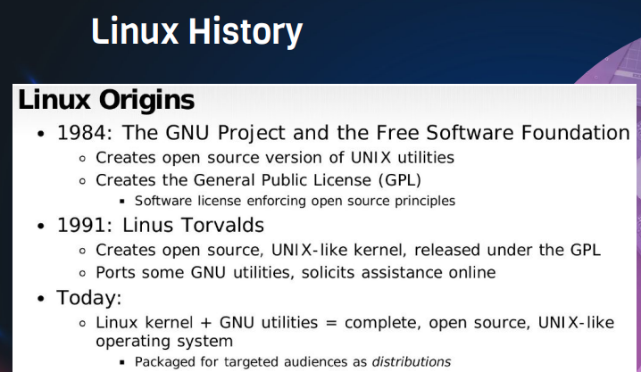

Contents

1.Intro to Linux

2. Basic CLI Commands

3. Understanding files in Linux

4. Filters & Redirection

5. Users & Group

6. Sudo

7. Software management

8. Services & Processes

9. Good to know commands

10. Server Management

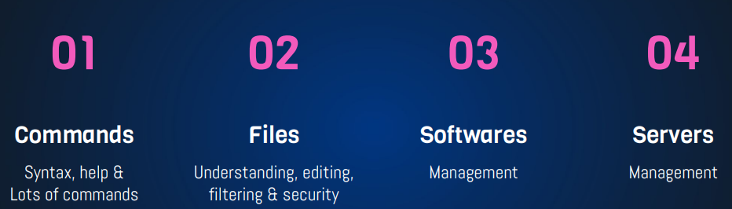

Open source : “Open source software is software with source code that anyone can inspect, modify, and enhance.”

Common Misconception: “Doesn't "open source" just mean something is free of charge?

Linux Principles:

* Everything is a file (Including Hardware)
* Small Single purpose Programs
* Ability to chain programs together for complex operations
* Avoid Captive User Interface
* Configuration data stored in text file

Why Linux?

● Opensource ● Community Support ● Support Wide Variety of Hardware ● Customization ● Most Servers runs on Linux ● Automation ● Security

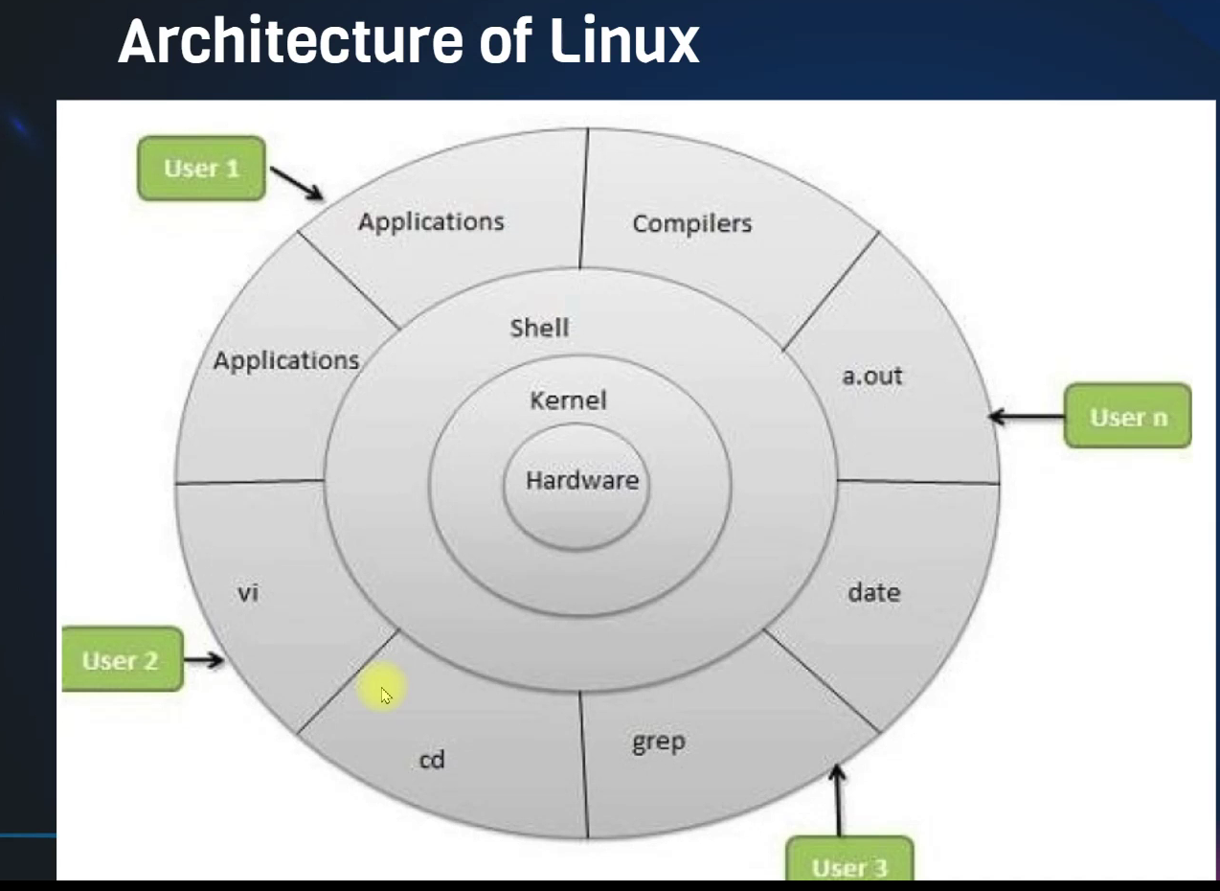

Popular Linux distros:

* Ubuntu Linux
* Linux Mint
* Arch Linux
* Fedora
* Debian
* OpenSUSE

Popular Server Linux OS

* Red Hat Enterprise Linux
* Ubuntu Server
* Centos
* SUSE Enterprise Linux

Most used Linux distros currently in IT industry:

* RPM based: - RHEL, Centos, Oracle Linux
* Debian based: - Ubuntu Server, Kali Linux

The difference between two operating system is the **package method** of software.

* RPM base mean you have software with package in RPM format like exe, MSI, APK etc
* DEB for Debian format

Red hat is consider as a stable and secure operating system 🡪 red hat enterprise Linux (we can’t download and install software like RHEL Linux from outside(you can download and install only from red hat repository🡪 red hat is going to test all the package and software before release it’s to user) same like apple(for the application purpose we can use Red hat Linux system)

But for Debian based, you get lots of software available freely, it is automation(for the devops we can use Debian based )

RPM based software that end’s with rpm

Debian based software that end’s with Deb

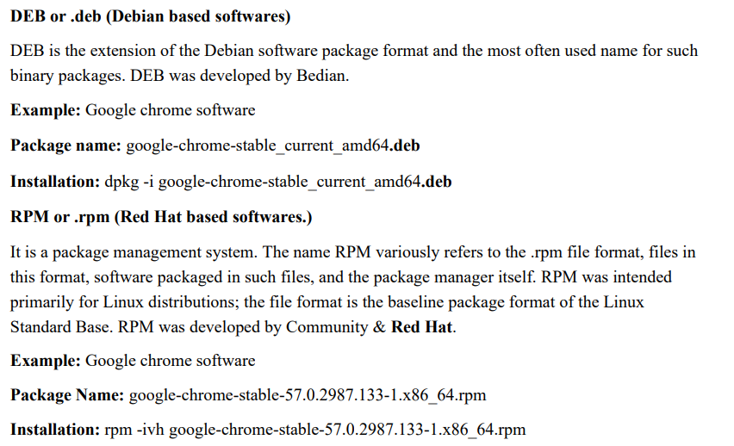

# Some of important directories

Home directories /root, /home/username - -- user directories

User executable /bin, /usr/bin,/usr/local/bin in this command will be executed by normal user

System executable /sbin, /usr/sbin, /usr/local/sbin in this command will be executed by root user

Other mountpoint /media , /mnt if you are connected external device like USB / Pen drive it automatically mounted to /media , /mnt

Configuration /etc **configuration date will store in etc**

Kernal and bootloader /boot Kernal and bootloader

Temporary files /tmp

Server data /svr, /var websever files / data will be they here

System information /sys,/proc system information like uptime, free-m

Shared libraries /lib, /usr/lib, /usr/local/lib shared lib

editable-text-configurations(etc)

file system:

explore the file systems like /bin,/sbin, /etc , /var, /lib, /boot etc

if you doubt’s try the **command –help**

**ex :** cp - -help

**check the devops learning🡪 linux command for refernce**

**cp , mv, rm, mdkir, touch, cat, vi, ls, whoami, pwd, hostname etc**

**Linux syntax :**

**command options arguments**

**ls**

**ls -l**

**ls -ltr /tmp/devops**

**cp -r ops/ dev/ (we can google it for the commands)**

Some commands you can use:

cat /etc/os-release 🡪 to see version, name etc

I can change hostname by both ways in root user **vim /etc/hostname** or **hostname “give the hostname”**

cat /etc/passwd

disk restoration

# VIM editor

It has 3 modes:

1 Command Mode

1 command mode

2 Insert mode (edit mode) 🡪 we can insert text/anything by “i”

3 extended command mode 🡪 “esc--> : “ we can do to extended

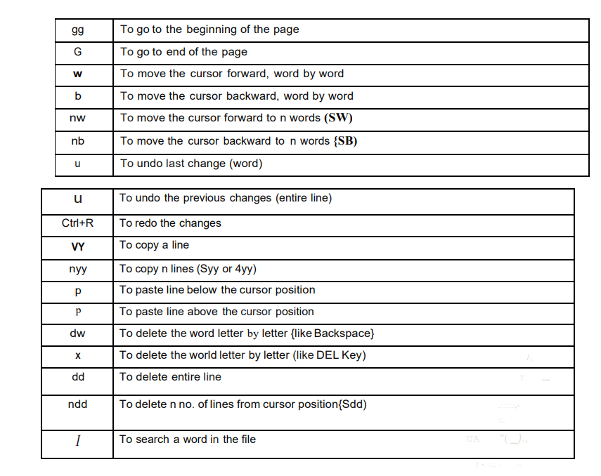

“G == shift + g” (any character)

Follow the multiple line max 4yy, 5dd it can used for single line

“/” for the search

**file** command 🡪 used to find type of file

ex : [root@CentOSVM bin]# file yum

**yum: symbolic link to dnf-3**

[root@CentOSVM bin]# file /bin/pwd

**/bin/pwd: ELF 64-bit LSB pie executable, x86-64, version 1 (SYSV), dynamically linked, interpreter /lib64/ld-linux-x86-64.so.2, BuildID[sha1]=8ec337e5943ad8796f8c8c1ffe174660fce67d20, for GNU/Linux 3.2.0, stripped**

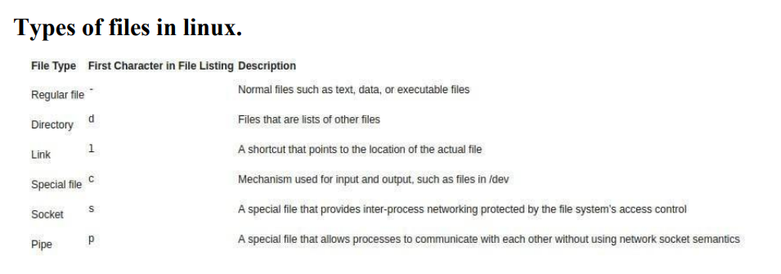

ln -s dev/ops/devops/testing/commands cmds

-s, --symbolic make symbolic links instead of hard links

mdkir -p ops/ dev/

-p, --parents no error if existing, make parent directories as needed

# Filter

Grep: (search operation)

grep [search-word, anything] [path]

example: grep firewall anaconda ks.cfg (it case sentive)

grep -i firewall < anaconda ks.cfg (it is not case sentive) ( ‘< ’ input redirection symbol is invisible here)

grep -IR firewall * (now it can search in directory also )

grep -vi firewall anaconda (-v is like revere it won’t display the firewall)

less and more command **for reader** ( we can read content) **like vim editor** but we can use to read only

* less anaconda ks.cfg
* more anaconda ks.cfg
* head anaconda ks.cfg
* tail anaconda ks.cfg
* head -20 anaconda ks.cfg
* tail -20 anaconda ks.cfg
* tail -f anaconda ks.cfg - it display’s dynamic content {🡪 control c 🡪 to quit }

## to filter the well structure row’s

cut delimiter (separate ‘:’) -flied path

**cut -d: -f1 /etc/passwd**

## to filter that not well structure row’s

awk -F’:’ ‘{print $1}’ /etc/passwd 🡪 it also a best way search

aws -F ‘separator’ ‘{print $1}’🡪 column need to search path

## Replace 🡪 sed command

1. Vim simplefile.txt

:%s/coronavirus/covid19/g 🡪:%s/exiting-word/replace-word/g(g for global)

1. sed ‘s/ coronavirus/covid19/g’ simplefile.txt 🡪 it won’t anything just display the changes
2. sed -i ‘s/ coronavirus/covid19/g’ simplefile.txt 🡪 with option -i it will replace every ware.
3. sed ‘s/ coronavirus/covid19/g’ *

----------------------------------------------------------------------------------------------------------------------------

# I/O redirection

In Linux and Unix-like operating systems, redirection symbols are used to control the input and output of commands and processes. These symbols allow you to manipulate how data flows between commands, files, and devices. Here are some common redirection symbols and their explanations:

1. **> (Output Redirection)**:
   * Syntax: **command > file**
   * Explanation: Redirects the standard output (stdout) of **command** to **file**. If **file** does not exist, it will be created. If it already exists, its contents will be overwritten.
2. **>> (Append Output)**:
   * Syntax: **command >> file**
   * Explanation: Appends the standard output (stdout) of **command** to **file**. If **file** does not exist, it will be created. If it already exists, data is added to the end without overwriting existing content.
3. **2> (Error Redirection)**:
   * Syntax: **command 2> file**
   * Explanation: Redirects the standard error (stderr) of **command** to **file**. Useful for capturing error messages separately from regular output.
4. **2>> (Append Error)**:
   * Syntax: **command 2>> file**
   * Explanation: Appends the standard error (stderr) of **command** to **file**.
5. **< (Input Redirection)**:
   * Syntax: **command < file**
   * Explanation: Takes the input for **command** from **file** instead of the keyboard. It reads data from **file** and passes it as input to **command**.
6. **| (Pipe)**:
   * Syntax: **command1 | command2**
   * Explanation: Redirects the output of **command1** as the input of **command2**. This allows you to chain commands together, with the output of one command becoming the input of another.
7. **<< (Here Document)**:
   * Syntax: **command << delimiter**
   * Explanation: Allows you to specify a block of text as input to **command**. You provide the text between **<< delimiter** and **delimiter**, and it is treated as input to **command**.
8. **<<< (Here String)**:
   * Syntax: **command <<< "string"**
   * Explanation: Provides a string as input to **command**. The string is passed as input to the command without the need for a file or a here document.
9. **&> (Redirect Both stdout and stderr)**:
   * Syntax: **command &> file**
   * Explanation: Redirects both the standard output (stdout) and standard error (stderr) of **command** to **file**.
10. **2>&1 (Redirect stderr to stdout)**:
    * Syntax: **command 2>&1**
    * Explanation: Redirects the standard error (stderr) of **command** to the same location as the standard output (stdout). This is often used to capture both regular output and error messages in a single file or pipe.

These redirection symbols are powerful tools for managing input and output in the Linux command line. They allow you to control where data comes from and where it goes, making it easier to automate tasks and work with files and processes efficiently.

Some commands:

date 🡪 to check date &time

uptime 🡪 to check the uptime of user

free -m 🡪 it display the RAM & memory

df -h 🡪 it display the disk utility

/dev/null 🡪it like void “nothing is exit is here”

Wc -l 🡪 to count the lines

## Find -command:

1. find /etc -name host* 🡪 we can search in root directory / but it will slowdown the system because it is real time search

instead use locate 🡪 it is not real time so make sure before running locate run the command updatedb

1. yum install mlocate -y

updatedb

locate host*

# Users & Groups

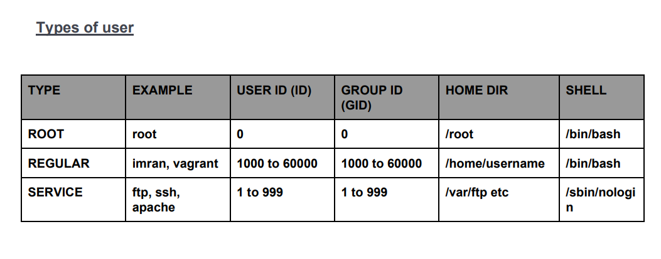

To add use useradd aws (centOS)

Groupadd devops

To add the user in to group 🡪 usermod -aG devops aws

Or vim /etc/group add the user by “,”

🡪to delete the group, user 🡪 **userdel** , **groupdel**

To see the open files lsof by the user (in this case user: vagrant)

Ex : lsof -u vagrant

Lsof -u aws

🡪 userdel -r Jenkins

Groupdel devops

# File permissions

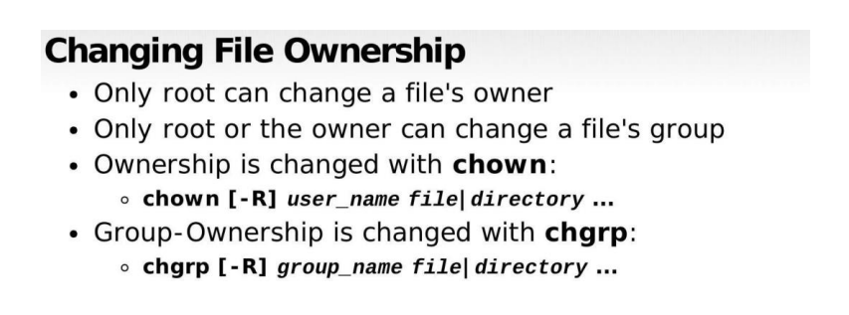

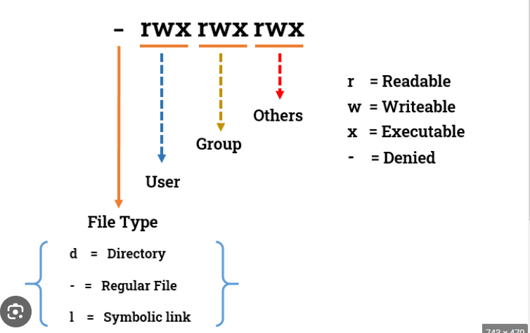

chown ansible:devops /opt/devopsdir

chown -R ansible:devops /opt/devopsdir (-r recursively change own to all the file in directory use carefully) we can use ‘:’ or ‘.’ As separator

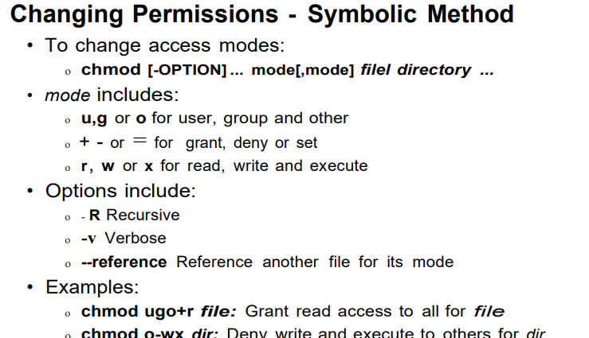

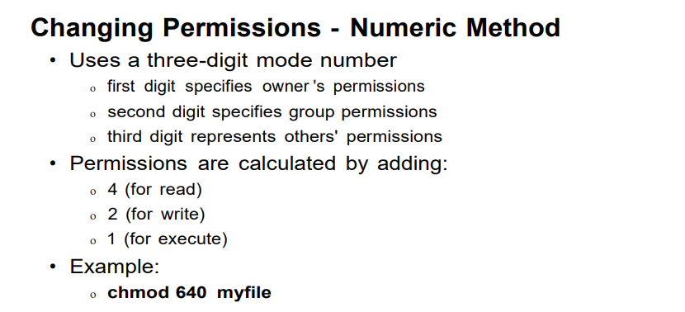

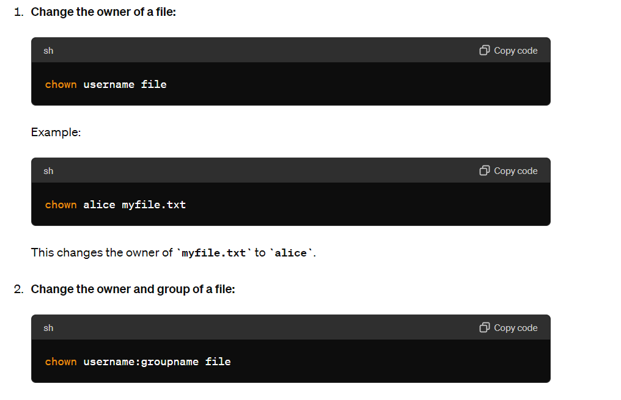

1. chmod 770 /opt/webdata
2. ls -ld /opt/webdata/
3. chmod 000 /opt/webdata
4. chmod 777 /opt/webdata
5. ls -ld /opt/webdata/

----------------------------------------------------------------------------------

# SUDO

sudo gives power to a normal user to execute commands which is owned by root user.

If a user has already full sudoers privilege, it can become a root user anytime.

If you want to change permission sudoers then

Visudo 🡪 changes like 🡪(( no place in visudo))

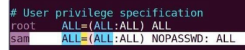

Ansible ALL=(ALL) NO PASSWD : ALL 🡪Next it won’t ask the password while you switching user

But if you modify any with syntax error and save it by mistake , then we can’t able edit(it required a root password(we didn’t create it)

To void this , use

cd /etc/sudoers.d/

ls

cat vagrant

cp vagrant devops

vim devops 🡪 devops ALL:(ALL) NO PASSWD:ALL

cat *

now can able to do the same without editing sudo file

Software Management

To install software we can you **curl link.rmp -o name.rmp** ,if they is no dependences we can use this. But some of the software package have more dependences in that care **yum** can be used.

YUM command automatically download all the dependences in rmp system

Ex:

To install Tree # curl https://rpmfind.net/linux/centos/7.9.2009/os/x86_64/Packages/tree-1.6.0-10.el7.x86_64.rpm -o tree-1.6.0- 10.el7.x86_64.rpm

rpm -ivh tree-1.6.0- 10.el7.x86_64.rpm

But we can’t install like this for httpd because of dependences so we can use yum

yum install httpd -y

we can see package sources where yum command used to download packages and the dependences:

cd /etc/yum.repos.d/

yum search httpd 🡪 we can see all the packages available

we can remove packages 🡪 yum remove httpd

if you not find software search in google 🡪 see the devops meteral for more yum commands

# services

if you **install any packages** then you have **service** on it , to manage the service by using **systemctl .**

**ex : yum install httpd -y**

**systemcl status httpd (status, start, enable , stop, is-active, enable etc)**

**systemctl is-enabled httpd**

when we give the systemctl command it goto the configuration

“cat /etc/systemd/system/multi-user.target.wants/httpd.service”

Reach for service(like start ) and run the command

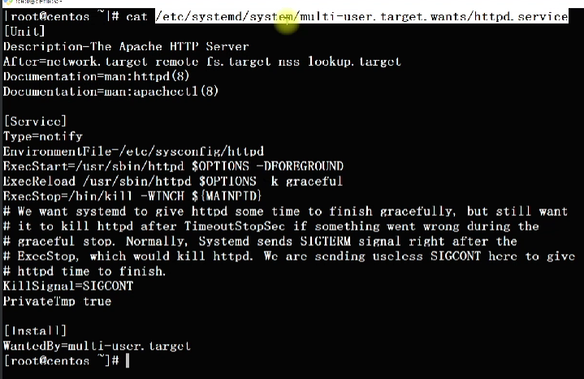

# Processes

They are so many process run the system it consume some if RAM & CPU

## Top command :

It is see the dynamtically processes are running , it similar to task manager in system. To quit press Q

## ps aux command:

it is similar to the TOP COMMAND but display in screen and quits , it can sort as per PID..etc

## ps -ef command :

it also similar but it didn’t show utility but it show parent process id (ppid)

441 top

442 clear

443 ps aux

444 clear

445 ps -ef

446 clear

447 ps -ef | grep httpd

448 ps -ef | grep httpd | grep -v 'grep'

449 kill 1420

450 ps -ef | grep httpd | grep -v 'grep'

451 systemctl start httpd

452 ps -ef | grep httpd | grep -v 'grep'

453 kill -9 1476

454 ps -ef | grep httpd | grep -v 'grep'

455 clear

456 ps -ef | grep httpd | grep -v 'grep'

457 ps -ef | grep httpd | grep -v 'grep' | awk '{print $2}'

458 ps -ef | grep httpd | grep -v 'grep' | awk '{print $2}' | xargs kill -9

459 systemctl start httpd

460 ps -ef | grep httpd | grep -v 'grep' | awk '{print $2}'

461 ps -ef | grep httpd | grep -v 'grep' | awk '{print $2}' | xargs kill -9

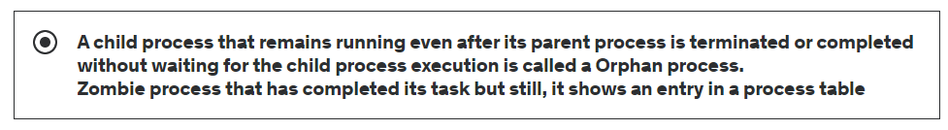

# Archiving

## Tar ball

**tar** (short for Tape Archive) is a command-line utility in Unix and Unix-like operating systems that is used for creating and manipulating archive files. Tar archives are used to combine multiple files and directories into a single file for various purposes, such as data backup, data compression, and transferring files from one system to another. Here's a breakdown of what **tar** archiving is and why it is needed:

1. **Combining Files and Directories:** One of the primary purposes of **tar** is to combine multiple files and directories into a single archive file. This is useful for creating a single file that contains all the data you want to back up or transfer.
2. **Compression:** While **tar** itself doesn't provide compression, it is often used in conjunction with compression utilities like **gzip** or **bzip2**. This allows you to create compressed archive files, which save storage space and reduce transfer times when moving data over a network or archiving data for long-term storage.
3. **Preserving File Attributes:** Tar archives can preserve various file attributes such as ownership, permissions, timestamps, and symbolic links. When you extract files from a **tar** archive, these attributes are restored, which is important for maintaining the integrity of the data.
4. **Transport and Distribution:** When you need to transfer a large number of files or directories to another location, such as a remote server, it's often more efficient to create a single archive file and then transfer that file. This reduces the overhead associated with transferring many individual files.
5. **Backup:** Tar archives are commonly used for creating backups of files and directories. By creating regular backups, you can protect your data from accidental deletion, hardware failures, or other data loss scenarios.
6. **Archiving and Packaging:** Software distributions and installation packages are often distributed in **tar** archives. This allows software developers to package all the necessary files and directories together and distribute them as a single archive.
7. **Compatibility:** Tar archives are widely supported on Unix and Unix-like systems, making them a versatile and standard way to package and transfer data.
8. **Scripting and Automation:** **tar** can be easily integrated into scripts and automation workflows, allowing for the automated creation and extraction of archive files.

Here are some common **tar** commands:

* **tar -cvf archive.tar file1 file2 ...**: Create a new tar archive (**-c**) with the specified files.
* **tar -xvf archive.tar**: Extract the contents of a tar archive (**-x**).
* **tar -czvf archive.tar.gz directory**: Create a compressed tar archive with gzip compression (**-z**).
* **tar -tf archive.tar**: List the contents of a tar archive (**-t**).
* **tar -rvf archive.tar newfile**: Append a file to an existing tar archive (**-r**).

Overall, **tar** is a versatile and essential tool in the Unix/Linux world for managing and handling collections of files and directories.

Eg : tar -czvf jenkins_06122020.tar.gz Jenkins

mv jenkins_06122020.tar.gz /tmp/

tar -xzvf jenkins_06122020.tar.gz

tar -xzvf jenkins_06122020.tar.gz -C /opt/

## zip /unzip

zip -r jenkins_06122020.zip jenkins

ls -ltr jenkins*

mv jenkins_06122020.zip /opt/

cd /opt/

ls

rm -rf jenkins

unzip jenkins_06122020.zip

ls

clear

## Difference b/w centos & ubuntu

Refer the linux camand for more info

Instead of useradd we need to adduser in ubuntu

It is Debian based system ‘.deb ’ package need to install

Instead of **rpm** here **dpkg -i**

We can see the repos in **/etc/apt** 🡪 **cat sources.list**

Instead of yum Debian use **apt 🡪 apt update & apt install apache2 -y**

**Etc**

**apt purge apache2 🡪 it is clean uninstall/remove** (it will remove everything related to this)

# VAGRANT & Linux server

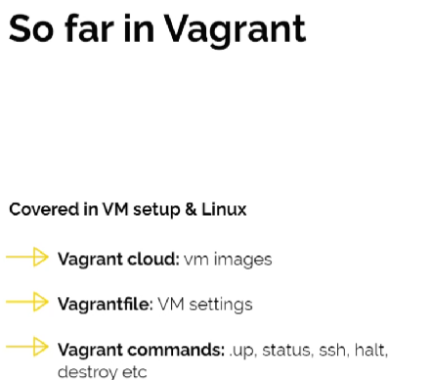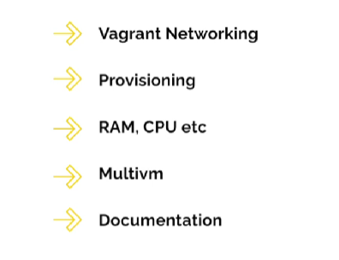

## Vagrant file

Vagrant.configure("2") do |config|

config.vm.box = "eurolinux-vagrant/centos-stream-9"

config.vm.network "private_network", ip: "192.168.56.15"

config.vm.network "public_network"

config.vm.provider "virtualbox" do |vb|

vb.memory = "1024"

vb.cpus = "2"

end

config.vm.provision "shell", inline: <<-SHELL

**yum install httpd wget unzip git -y**

**mkdir /opt/devopsdir**

**free -m**

**uptime**

SHELL

End

## Vagrant sync driectories

In vagrant 🡪 when preforming the vagrant up “you can notes the guest path : host path” in sysnc, changes/file is created/placed in host you can see the same file in guest also.

We can changes this path in vagrant file

Config.vm.syncd_folder “F:\\scripts\\shellscrpts” , “/opt/scripts”

We can use any editor and using sync we can transfer files easily

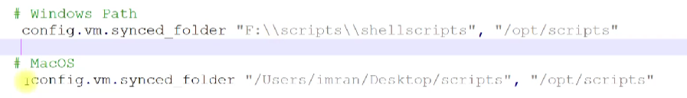

## Provisioning/ bootstrapping:

**vagrant --provision-** command use for apply provision changes in exiting vm

See the “see the vagrant file ” in above the page.

If command ask any question the provision will fail,

“”

**yum install httpd wget unzip git -y**

**mkdir /opt/devopsdir**

**free -m**

**uptime**

“”

## Website setup

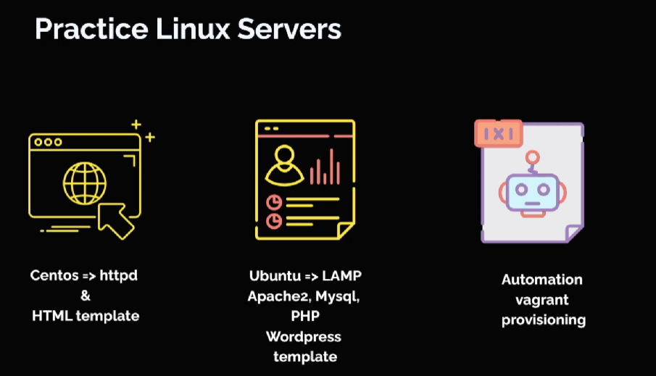

LAMP stack => linux apache mysql pip

Both manual & automatic with provision

You can search

Using tooplate :

mkdir /tmp/scripts

sudo yum install httpd wget unzip -y

systemctl start httpd

systemctl enable httpd

cd /tmp/scripts

wget <https://github.com/startbootstrap/startbootstrap-grayscale/archive/gh-pages.zip>

unzip -o [gh-pages.zip](https://github.com/startbootstrap/startbootstrap-grayscale/archive/gh-pages.zip) (if this files exit then -o is override the files)

cp -r startbootstrap-grayscale.gh-pages/* /var/www/html

systemctl restart httpd

rm -rf /tmp/scripts

search for ip addr of bridged adapter 🡪ip addr show

get the ip address and run in Brower

**some times firewall we get issue check for it**

systemctl status firewall

systemctl stop firewall

systemctl disab firewall

## wordpress setup:

Both manual & automatic with provision

sudo apt update

sudo apt install apache2 \

ghostscript \

libapache2-mod-php \

mysql-server \

php \

php-bcmath \

php-curl \

php-imagick \

php-intl \

php-json \

php-mbstring \

php-mysql \

php-xml \

php-zip -y

sudo mkdir -p /srv/www

sudo chown www-data: /srv/www

curl https://wordpress.org/latest.tar.gz | sudo -u www-data tar zx -C /srv/www

cat > /etc/apache2/sites-available/wordpress.conf **<<EOF**

<VirtualHost *:80>

DocumentRoot /srv/www/wordpress

<Directory /srv/www/wordpress>

Options FollowSymLinks

AllowOverride Limit Options FileInfo

DirectoryIndex index.php

Require all granted

</Directory>

<Directory /srv/www/wordpress/wp-content>

Options FollowSymLinks

Require all granted

</Directory>

</VirtualHost>

**EOF**

sudo a2ensite wordpress

sudo a2enmod rewrite

sudo a2dissite 000-default

mysql -u root -e 'CREATE DATABASE wordpress;'

mysql -u root -e 'CREATE USER wordpress@localhost IDENTIFIED BY "admin123";'

mysql -u root -e 'GRANT SELECT,INSERT,UPDATE,DELETE,CREATE,DROP,ALTER ON wordpress.* TO wordpress@localhost;'

mysql -u root -e 'FLUSH PRIVILEGES;'

sudo -u www-data cp /srv/www/wordpress/wp-config-sample.php /srv/www/wordpress/wp-config.php

sudo -u www-data sed -i 's/database_name_here/wordpress/' /srv/www/wordpress/wp-config.php

sudo -u www-data sed -i 's/username_here/wordpress/' /srv/www/wordpress/wp-config.php

sudo -u www-data sed -i 's/password_here/admin123/' /srv/www/wordpress/wp-config.php

systemctl restart mysql

systemctl restart apache2

**Infrastructure as code** (**IaC**) is the process of managing and provisioning infrastructure (networks, virtual machines, load balancers, and connection topology) through CODE/Config Files.

E:g

Vagrant for local  
Terraform for Cloud  
Ansible for Servers

Cloudformation for AWS

etc

Top of Form

Provisioning is the process of configuring and deploying an information technology (IT) system resource either locally or in the cloud. In enterprise computing, the term is often associated with virtual machines (VMs) and cloud resource instances.

* **True**
* **False**

Bottom of Form

## MultiVM Vagrant file :

Vagrant.configure("2") do |config|

config.vm.define "web01" do |web01|

web01.vm.box = "ubuntu/focal64"

web01.vm.hostname = "web01"

web01.vm.network "private_network", ip: "192.168.56.41"

end

config.vm.define "web02" do |web02|

web02.vm.box = "ubuntu/focal64"

web02.vm.hostname = "web02"

web02.vm.network "private_network", ip: "192.168.56.41"

end

config.vm.define "web03" do |web03|

web03.vm.box = "ubuntu/focal64"

web03.vm.hostname = "web02"

web03.vm.network "private_network", ip: "192.168.56.44"

end

config.vm.define "db01" do |db01|

db01.vm.box = "centos/7"

db01.vm.hostname = "db01"

db01.vm.network "private_network", ip: "192.168.56.42"

db01.vm.provision "shell", inline: <<-SHELL

yum install -y wget unzip mariadb-server -y

systemctl start mariadb

systemctl enable mariadb

# Additional provisioning steps for db01

SHELL

end

end

# Variable Json & YAML

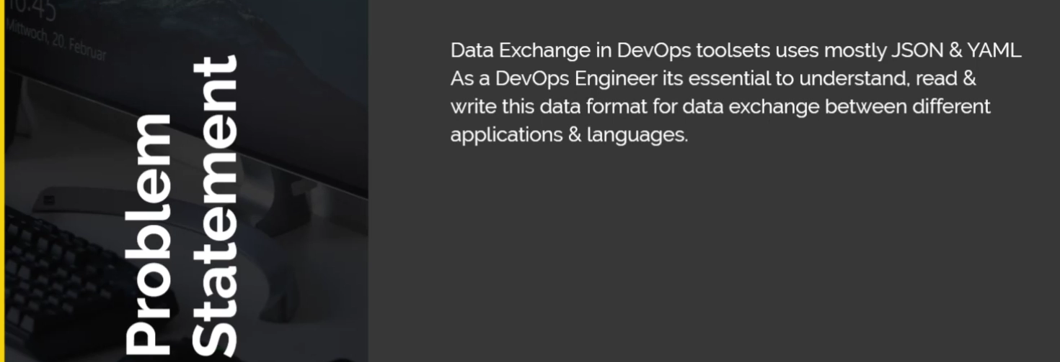

Variables🡪python DS 🡪JSON 🡪YAML

## Variables

In bash :

$Skill=”deployment_engineer” (assign value(deployemt_enginer to varible skill)

$Echo “I am working in $Skill ”

“I am working in deployment_engineer

Note :(if you double quotation (“”) it takes variable in $ symbol but if we use the single (‘’) it will consider as a text for $ symbol also

If you user

$ Echo 'I am working in $Skill ‘

I am working in $Skill

$Echo ‘I am working in “$Skill” ‘

“I am working in deployment_engineer

Python got the Gims of variable , set, list & tiple

Particle this

Variable :

Skill =” deployment engineer”

Number=123

Print (“I am working on :“,skill,”years :”,number”

#variable

skill="devops"

print(skill)

#list

ls=["ram","ravi","jenva",1,3,2,1]

print(ls)

#set

st={"ram","ravi","jenva",1,3,2,1}

print(st)

#triple

tp=("ram","ravi","jenva",1,3,2,1)

print(tp)

#dictoriory

dt={"skill":"devops","tools":("jenkins","aws","linux","container"),"number":123 }

print(dt)

print(dt["skill"])

print(dt["skill"][0])

output:

devops

['ram', 'ravi', 'jenva', 1, 3, 2, 1]

{1, 2, 3, 'ram', 'ravi', 'jenva'}

('ram', 'ravi', 'jenva', 1, 3, 2, 1)

{'skill': 'devops', 'tools': ('jenkins', 'aws', 'linux', 'container'), 'number': 123}

devops

d

# JSON &YAML

Python:

dt={ "skill":"devops",

"tools":(

"jenkins",

"aws",

"linux",

"container"),

"number":123

}

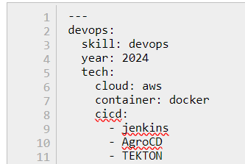devops:

skill: devops

year: 2024

tech:

cloud: aws

container: docker

cicd:

- jenkins

- AgroCD

- TEKTON

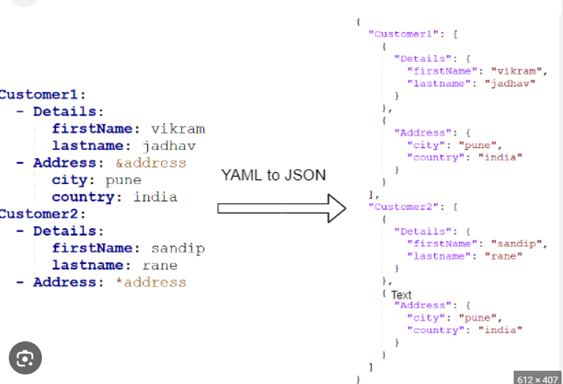

# Vprofile Project setup manual & automated

Refer the document /devops learning

devOps learning\ddc-material-master\06.ProjectSetupLocal

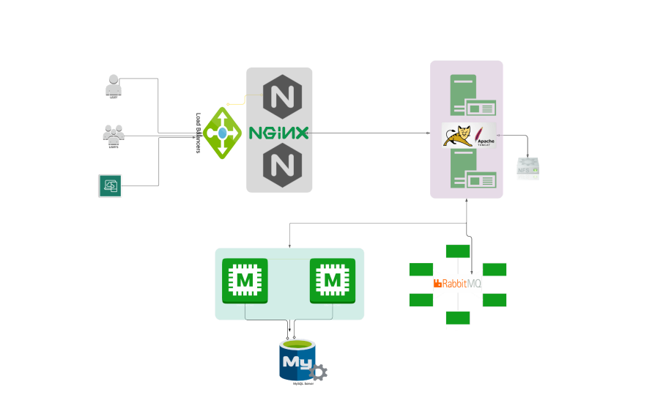

Vagrant.configure("2") do |config|

  config.hostmanager.enabled = true

  config.hostmanager.manage_host = true

hostmanger is one of **the plugins of vagrant** 🡪when we enter the both ip address and host name in vagrant file it make sure **/etc/host has matching host name and ip address**

in multi machine environment where one machine connect to other machine’s and the way of connecting though ip address and ip address may change a it’s complicated to mention ip address, so we always go with host name

### ping test:

ping web01 -c 4 🡪 4 count’s package we sent , if it failing then something wrong while bring up the vm .

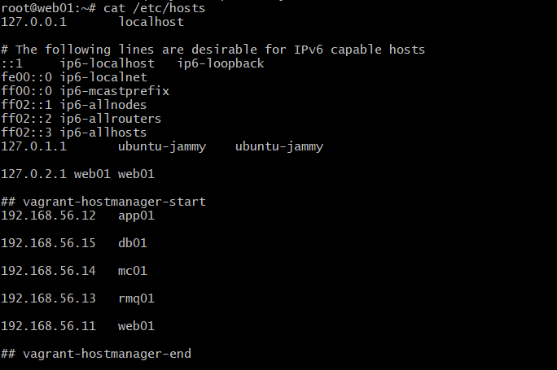

Setup should be done in below mentioned order

1. MySQL (Database SVC)

2. Memcache (DB Caching SVC)

3. RabbitMQ (Broker/Queue SVC)

4. Tomcat (Application SVC)

5. Nginx (Web SVC

**It is ideal practice setup to any stack 🡪 stack is combination of multiple services**

Cluster is group of system running on same service

**Starting application** 🡪 backend service🡪app 🡪web

**Stopping application** 🡪 web🡪app🡪backend service

**It is not mandatory but good practice**.

## Backend-service:

Install the database🡪 sudo yum install mariadb-server -y 🡪 start & and enable it

Set the password secure 🡪 mysql_secure_installation

Check the database 🡪 mysql -u root -padmin (u = user(root) p = password(admin)

Create a database : mysql database accounts

Great all pillages on accounts. *To ‘admin’@’%’ indentified by ‘admin123’;

FLUSH PRIVILEGES;

exit

Clone the repo vprofile to get the db_backup.sql tables

mysql -u root -padmin accounts < vprofile-project/

src/main/resources/db_backup.sql

GRANT ALL PRIVILEGES ON accounts.* TO 'admin'@'%' IDENTIFIED BY 'admin123';

### Explanation

1. **GRANT ALL PRIVILEGES**:
   * This part of the statement grants all possible permissions to the specified user. These permissions include SELECT, INSERT, UPDATE, DELETE, CREATE, DROP, INDEX, ALTER, etc.
2. **ON accounts.**\*:
   * This specifies the database and tables the privileges apply to.
   * accounts.* means all tables in the accounts database. If you wanted to apply the privileges to a specific table, you would use accounts.table_name.
3. **TO 'admin'@'%'**:
   * This specifies the user and the host from which the user can connect.
   * 'admin' is the username.
   * '%' is a wildcard that allows connections from any host. You can replace % with a specific IP address or hostname to restrict access.
4. **IDENTIFIED BY 'admin123'**:
   * This sets the password for the user admin to admin123.

### Usage

To execute this statement, you need to have administrative privileges on the MySQL server. Here’s how you can run it:

1. **Login to MySQL**:

sh

Copy code

mysql -u root -p

This command logs you into the MySQL server as the root user. You'll be prompted to enter the root password.

1. **Execute the GRANT Statement**:

sql

Copy code

GRANT ALL PRIVILEGES ON accounts.* TO 'admin'@'%' IDENTIFIED BY 'admin123';

This command grants the specified privileges.

1. **Flush Privileges** (Optional but recommended):

sql

Copy code

FLUSH PRIVILEGES;

This command reloads the privilege tables in MySQL, ensuring that the changes take effect immediately.

### Security Considerations

* **Using 'admin'**: The username admin is quite generic and could be a target for brute-force attacks. Consider using a more unique username.
* **Password Strength**: The password admin123 is weak. Use a stronger password to enhance security.
* **Host Wildcard '%'**: Allowing connections from any host (%) can be risky. Restrict access to specific IP addresses or hostnames if possible.

**see the table present all not and restart the servers**

Please refer devops learning document for clear installation

**Mamcached :**

Install mamcached and epel-release and start and enable the mamcached servers

Changes the system configuration so the it can connect different service from outside the vm

**Sed -I ‘s/127.0.0.0/0.0.0.0/g’ /etc/sysconfig/Memcached**

Restart the Memcached services

**Rabbit MQ:**

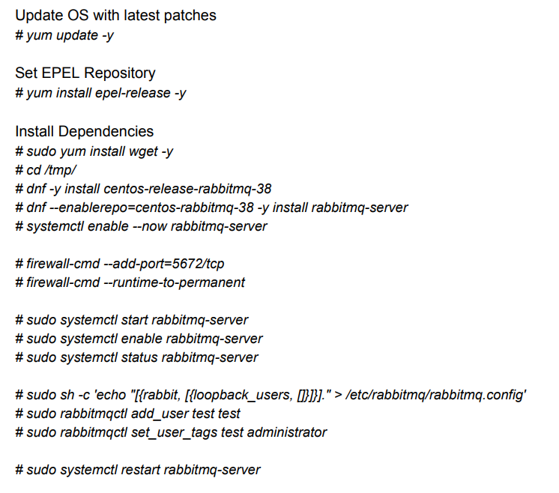

## APP SERVICES

In need to install the Apache tomcat but we are not able to install tomcat through yum

…Follow the documents…

## Web severs

Install nginx 🡪

Create Nginx conf file with below content

# vi /etc/nginx/sites-available/vproapp

upstream vproapp {

server app01:8080;

}

server {

listen 80;

location / {

proxy_pass <http://vproapp>; }

}

Listen’s on port 80 (http) and 4434(https)

80 🡪 it will route the request to <http://vproapp> 🡪 server app01 🡪 it enter the etc host file so app01 will translated to ip address:8080

Remove default nginx conf

# rm -rf /etc/nginx/sites-enabled/default

Create link to activate website

# ln -s /etc/nginx/sites-available/vproapp /etc/nginx/sites-enabled/vproapp

Restart Nginx #

systemctl restart nginx

## validate:

get the ip address web01 and launch it

note : once install and service enable check the status all service before logout. If service not active we make some syntax error. Check for the error a resolve it

## automation

write the every step in the from bash script add attached to vagrant file so in the time provisioning all the services enabled and connected to each other.

# NETWORKING

## Contents:

Here’s what you’ll find in this.

1. Components

2. OSI Model

3. Classification

4. Devices

5. Home Network

6. IP Addresses

7. Protocols

8. DNS & DHCP

9. Network Commands

What is a Computer Network?

Communication between two or more network Interfaces.

Every device you’re using on the network will have a Ip address assigned to its network Interfaces like laptop we have Ethernet adapter or wireless adapter, smart phones etc

**Components of Computer Network:**

1. Two or more computers/Devices

2. Cables as links between the computers

3. A network interfacing card (NIC) on each

4. computer

5. Switches

6. Routers

7. Software called Network operating system (NOS)

## OSI Model

● People around the world uses computer network to communicate with each other.

● For worldwide data communication, systems must be developed which are compatible to communicate with each other.

● There should be standard communication methods & devices.

● ISO (International Organization of Standardization) has developed this standard

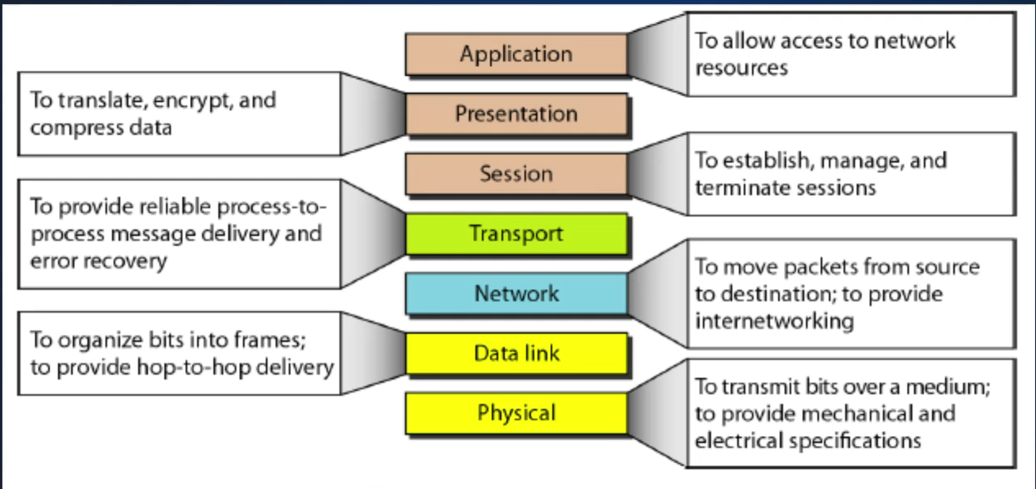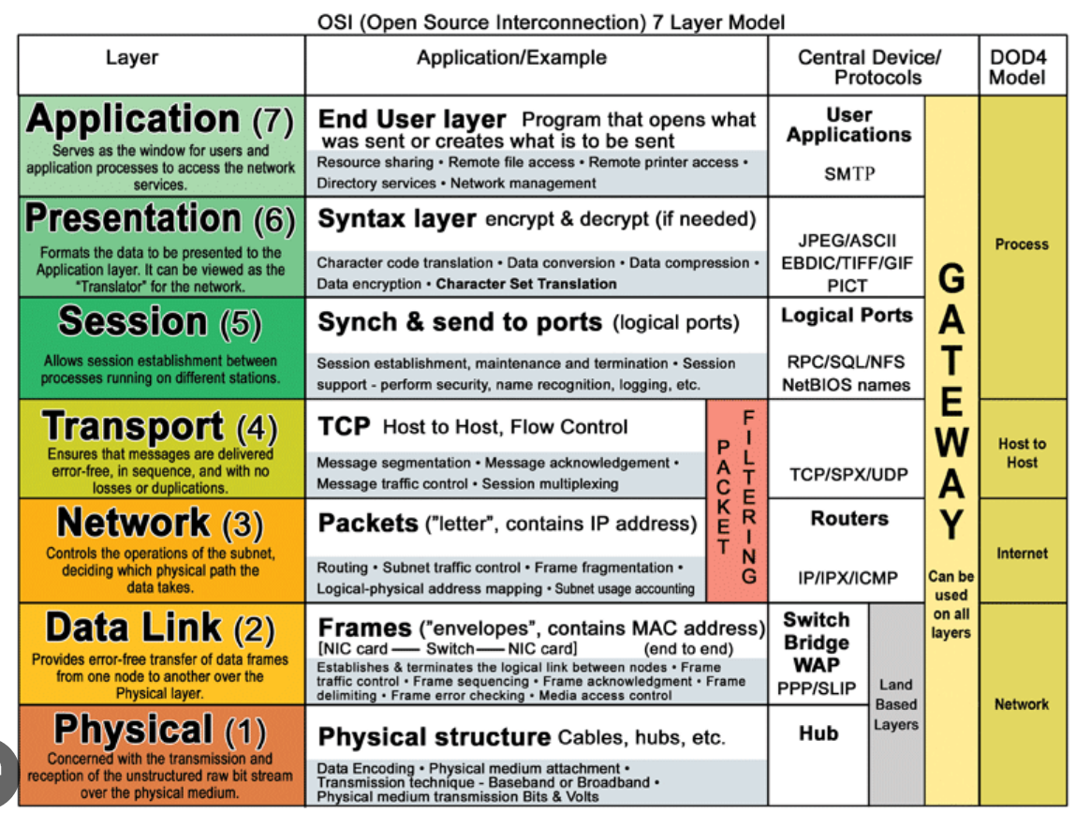

This communication model is called as Open System Interconnection (OSI).

ISO-OSI model is a seven layer architecture developed in **1984**.

The basic elements of a layered model are

* service
* protocols
* interfaces.

1. A service is a set of actions that a layer offers to another (higher) layer.

2. A Protocol is a set of rules that a layer uses to exchange information.

3. A Interface is communication between the layers

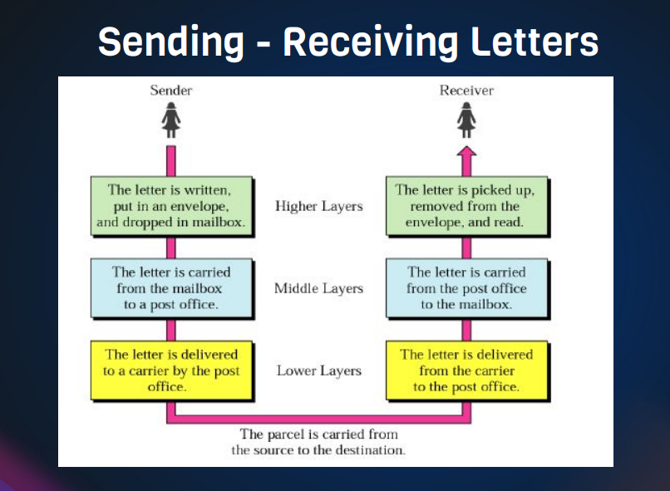

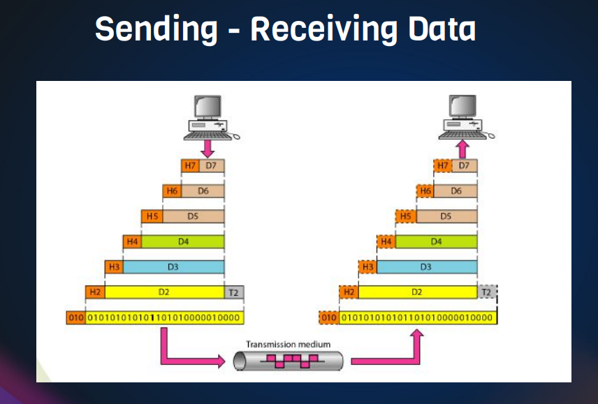

## Classification of network By Geography

➔ LAN

◆ Local area Network

➔ WAN

◆ Wide Area Network

➔ MAN

◆ Metropolitan area network

➔ CAN

◆ Campus Area Network

➔ PAN

◆ Personal Area Network

Switches:

Switches facilitate the sharing of resources by connecting together all the devices, including computers, printers, and servers, in a small business network

ROUTERS:

A router receives and sends data on computer networks. Routers are sometimes confused with network hubs, modems, or network switches. However, routers can combine Multiple Networks together.

## IPv4 Address:

32 bit binary number, which we see decimal format

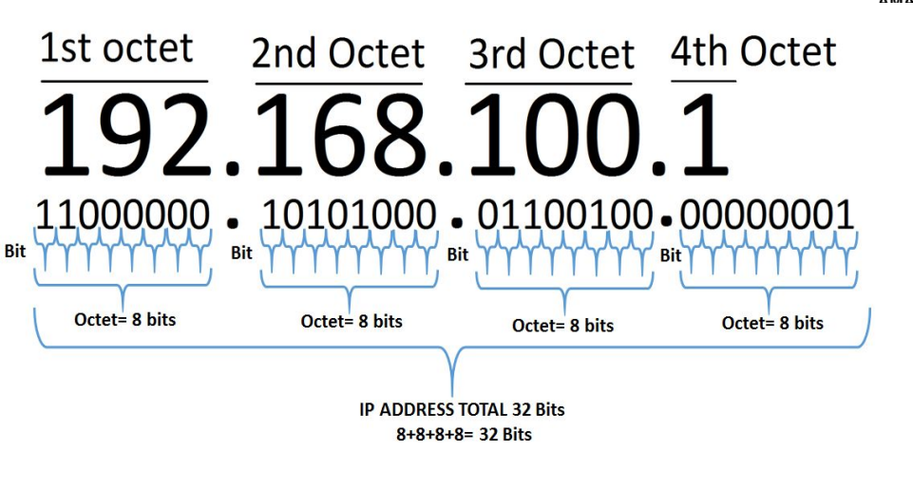

## IPv4 Range

• 0.0.0.0 – 255.255.255.255

• 00000000.00000000.00000000.00000000 (0.0.0.0)

• 11111111.11111111.11111111.11111111 (255.255.255.255

Public and Private IP Division

• Public IP => Internet • E:g 54.86.23.90

• Private IP => For local network design • E:g 192.168.1.10

## Private IP Ranges

● Class A 10.0.0.0 - 10.255.255.255

● Class B 172.16.0.0 - 172.31.255.255

● Class C 192.168.0.0 - 192.168.255.255

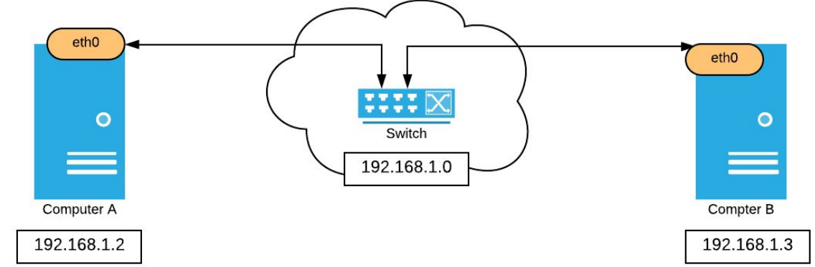

## Protocols

In the networking and communications area, a protocol is the formal specification that defines the procedures that must be followed when transmitting or receiving data. Protocols define the format, timing, sequence, and error checking used on the network.

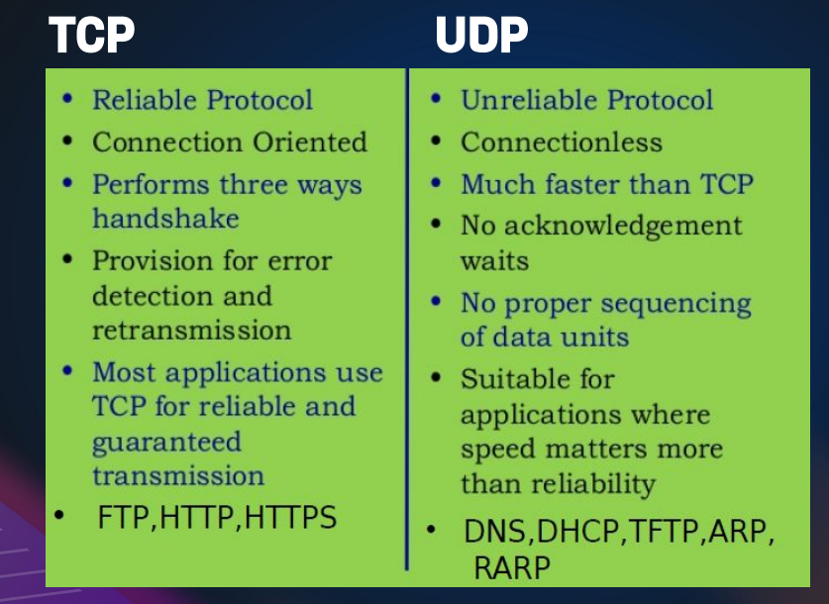

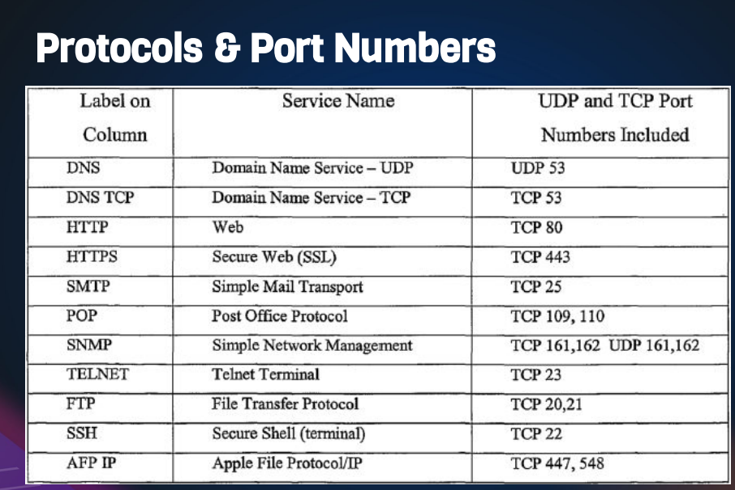

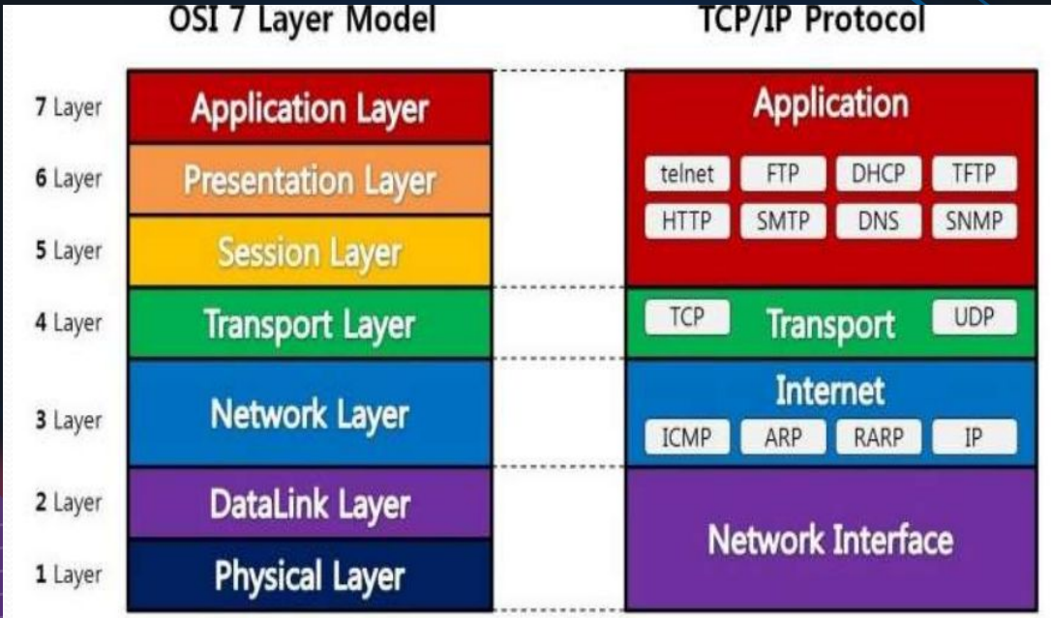

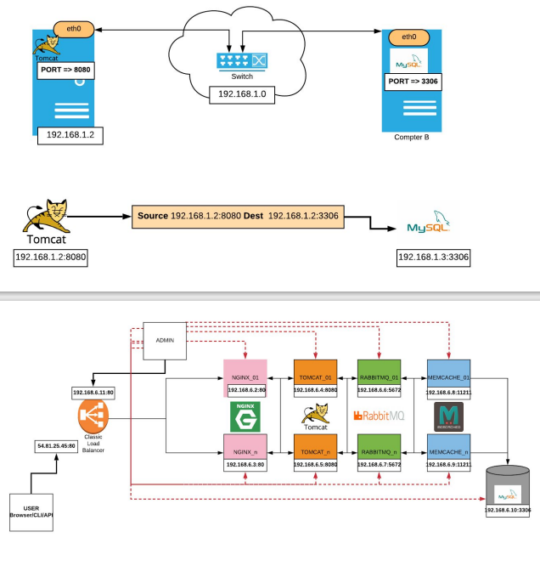

## Network commands

1)ipconfig/if config

2)ping 192.168.40.12

vi /etc/hosts

enter the ip address with name:

192.168.40.12 db01

3)ip addr show

4)tracert www.google.in( in window , i have tried) 🡪 see latance’s

it will do 8 hops to reach the google server

hops could be the routers, so it reached at this place(google sever), then took the next hop over here,

5)netstat -antp

it shows all the tcp point

ps -ef | grep apache2

ps-ef | grep 3336

6) ss -tunlp

for utp point

7)nmap

be carefully while using this command

we can scanner the port whether they are open are not (**nmap localhost**)

or **nmap db01**

1. dig [www.google.in](http://www.google.in)

dig shows the DNS look up , we can see the records for DNS Server

nslookup is also a similar command but older version of dig

9) nslookup www.google.in

10) route -n

route

getways 🡪 it is used to see Gateways

1. arp

this command is to view or add the content to the kernels ARP table

so kernel will maintain atable of all IP or name and mapping MAC address, so its saying for

**[root@localhost ~]# arp**

**Address HWtype HWaddress Flags Mask Iface_gateway ether 52:54:00:12:35:02 C enp0s3**

**10.0.2.3 ether 52:54:00:12:35:03 C enp0s3**

**_gateway ether 00:e0:4c:79:f9:e0 C enp0s9**

**[root@localhost ~]#**

12) mtr www.google.in

it simillar to the tracert but in the dynamically . so if you're getting a slow internet or in b/w two system is aslow connectivity. you can find

13 telnet 192.168.40.12 33306

# CONTAINERS

## Links:

<https://www.docker.com/resources/what-container/>

<https://docs.docker.com/get-started/overview/>

Container is an miniature operating system with they own file system (like directory). Normally we won’t install all software in one system because if we change one application/service configuration it will affect to other software/services. but using container engine we can configure/use the all services in one operating system in an isolated environment/file-system so that change of configuration in one service won’t affect the other services.

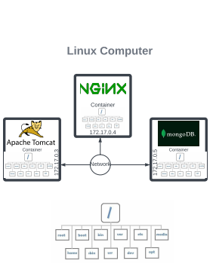

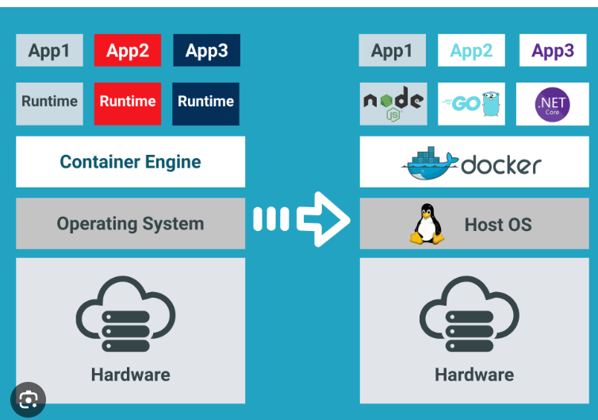

A container is a lightweight, standalone, and executable package that includes everything needed to run a piece of software, including the code, runtime, system tools, libraries, and settings. Containers are designed to be portable, scalable, and consistent across different environments, making it easier to deploy and manage applications in various computing environments, such as development, testing, and production.

Docker is a popular platform for creating, deploying, and managing containers. Here's a brief note on Docker containers:

**Docker Container**:

* **Definition**: A Docker container is an instance of a Docker image, which is a pre-packaged, immutable, and standalone software package that contains an application and all its dependencies.
* **Key Features**:
  1. **Isolation**: Containers provide process and filesystem isolation, allowing multiple containers to run on the same host without interfering with each other.
  2. **Portability**: Docker containers can run consistently across various environments, including developer laptops, test servers, and production servers.
  3. **Efficiency**: Containers share the host OS kernel, which makes them lightweight and efficient in terms of resource usage compared to traditional virtualization.
  4. **Version Control**: Docker images are versioned, making it easy to track changes and roll back to previous versions.
  5. **Orchestration**: Docker containers can be managed and orchestrated using tools like Docker Compose, Kubernetes, and Docker Swarm for scaling and load balancing.
  6. **Security**: Containers offer a level of isolation, but it's essential to implement security best practices to ensure the safety of containerized applications.
* **Use Cases**:
  1. **Microservices**: Docker containers are commonly used to package and deploy microservices, allowing for easy scaling and management of individual components of an application.
  2. **Continuous Integration/Continuous Deployment (CI/CD)**: Containers facilitate automated testing and deployment pipelines, ensuring consistent environments throughout the development and deployment lifecycle.
  3. **Multi-Platform Development**: Developers can create containers with consistent dependencies, allowing them to develop and test applications on their local machines and then deploy them in production environments seamlessly.

Docker containers have revolutionized the way applications are developed and deployed by simplifying the packaging, distribution, and management of software components, making it easier to build and maintain complex systems.

## Hands-on:

We can do the docker installation in vm provisioning :

sudo apt-get update

sudo apt-get install \

ca-certificates \

curl \

gnupg \

lsb-release -y

curl -fsSL https://download.docker.com/linux/ubuntu/gpg | sudo gpg --dearmor -o /usr/share/keyrings/docker-archive-keyring.gpg

echo \

"deb [arch=$(dpkg --print-architecture) signed-by=/usr/share/keyrings/docker-archive-keyring.gpg] https://download.docker.com/linux/ubuntu \

$(lsb_release -cs) stable" | sudo tee /etc/apt/sources.list.d/docker.list > /dev/null

sudo apt-get update

sudo apt-get install docker-ce docker-ce-cli containerd.io -y

sudo curl -L "https://github.com/docker/compose/releases/download/1.29.2/docker-compose-$(uname -s)-$(uname -m)" -o /usr/local/bin/docker-compose

sudo chmod +x /usr/local/bin/docker-compose

# Basic Commands

systemctl status docker

**docker run hello-world 🡪 we can test it/working or not**

docker images

docker ps 🡪for running container

docker ps -a 🡪 for all container

# Run a container

docker run --name web01 -d -p 9080:80 nginx

**(--name web01 🡪we can specify the name of container**

**-d this option used to run the command in background**

**-p 9080:80 -p is port we can specify because container run on internal network, so we can specify the port to access the container from outside 80 is container port and 9080 is the host port**

**Nginx is the services**)

docker ps

docker inspect web01

curl http://172.17.0.2:80

ip addr show

docker ps

# Go to browser enter IP:HostPort

# Building an Image

mkdir images

cd images/

vim Dockerfile

# Paste below content

FROM ubuntu:latest AS BUILD_IMAGE

RUN apt update && apt install wget unzip -y

RUN wget https://www.tooplate.com/zip-templates/2128_tween_agency.zip

RUN unzip 2128_tween_agency.zip && cd 2128_tween_agency && tar -czf tween.tgz * && mv tween.tgz /root/tween.tgz

FROM ubuntu:latest

LABEL "project"="Marketing"

ENV DEBIAN_FRONTEND=noninteractive

RUN apt update && apt install apache2 git wget -y

COPY --from=BUILD_IMAGE /root/tween.tgz /var/www/html/

RUN cd /var/www/html/ && tar xzf tween.tgz

CMD ["/usr/sbin/apache2ctl", "-D", "FOREGROUND"]

VOLUME /var/log/apache2

WORKDIR /var/www/html/

EXPOSE 80

# Build Image

docker build -t tesimg .

docker images

# Run container from our Image

docker run -P -d tesimg

docker ps

docker ps

ip addr show

docker ps

# Go to browser enter IP:HostPort

# CLEAN UP

docker ps

docker stop web01 heuristic_hugle

docker ps -a

docker rm heuristic_hugle web01 competent_gates elastic_ramanujan relaxed_sammet

clear

docker images

docker rmi a54ee9c44b3b 6130c26b5558 057d51c0049c 825d55fb6340 12766a6745ee feb5d9fea6a5

## docker compose

vim docker-compose.ymal

version: '3.8'

services:

vprodb:

image: vprocontainers/vprofiledb

ports:

- "3306:3306"

volumes:

- vprodbdata:/var/lib/mysql

environment:

- MYSQL_ROOT_PASSWORD=vprodbpass

vprocache01:

image: memcached

ports:

- "11211:11211"

vpromq01:

image: rabbitmq

ports:

- "15672:15672"

environment:

- RABBITMQ_DEFAULT_USER=guest

- RABBITMQ_DEFAULT_PASS=guest

vproapp:

image: vprocontainers/vprofileapp

ports:

- "8080:8080"

volumes:

- vproappdata:/usr/local/tomcat/webapps

vproweb:

image: vprocontainers/vprofileweb

ports:

- "80:80"

volumes:

vprodbdata: {}

vproappdata: {}

docker-compose up -d

docker-compose ps

docker compose down

docker system prune -a 🡪 this command remove’s all the stoped containers and remove all the image, if images are not used

# Microservices and Monolithic Services

## Link: https://aws.amazon.com/microservices/

## **Monolithic Services:**

A monolithic architecture is a traditional approach where an entire application is built as a single, self-contained unit. In a monolithic service, all components and functions of the application are tightly integrated into a single codebase and run as a single process

**Characteristics:**

1. Single Codebase: The entire application is developed in a single codebase, making it easier to manage but also potentially large and complex.
2. Tight Coupling: Components are tightly integrated, which can lead to dependencies and complexities when making changes.
3. Scalability: Scaling a monolithic application usually means replicating the entire application, which can be inefficient.
4. Development: Easier for small teams or simple applications, but becomes challenging as the codebase grows.
5. Testing and Deployment: Testing and deploying updates can be time-consuming, as changes may affect multiple parts of the application.

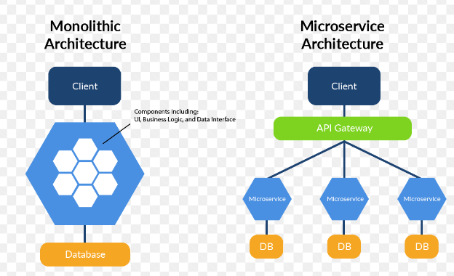

In monolithic architecture entity application build in single framework(like java etc

In Microservices, every services as it own framework (like one service NodeJS 🡪 mongo dB) other service use java with 🡪MySQL , other service use frontend with react js or angular)

Benefits:

Simplicity: Easier to develop and initially manage for small projects.

Code Sharing: Components can share code directly, reducing duplication.

Debugging: Easier to debug due to tight integration.

Drawbacks:

Lack of Flexibility: Difficult to adopt new technologies or languages.

Scalability Challenges: Scaling can be inefficient as the entire application must be replicated.

Complexity: Grows complex and harder to maintain as the application expands.

2. Microservices:

Microservices architecture breaks down an application into smaller, loosely coupled services, each responsible for a specific function or feature. These services communicate through APIs or other lightweight protocols.

Characteristics:

Decomposed Services: The application is divided into small, independently deployable services, each with its own codebase.

Loose Coupling: Services are loosely coupled, allowing for flexibility and independent development.

Scalability: Individual services can be scaled independently, optimizing resource usage.

Development: Easier to manage and scale as development teams can focus on specific services.

Testing and Deployment: Easier to test and deploy changes to individual services without affecting the entire application.

Benefits:

Scalability: Efficiently scale individual services to handle varying loads.

Flexibility: Easier to adopt new technologies or languages for specific services.

Maintenance: Easier to maintain and update as changes are isolated to specific services.

Drawbacks:

Complexity: Requires infrastructure for service discovery, load balancing, and communication.

Integration Challenges: Inter-service communication needs to be well-managed.

Overhead: Can introduce some operational overhead in managing multiple services.

In summary, the choice between microservices and monolithic services depends on the specific needs of your project. Monolithic services may be simpler for small projects, while microservices offer flexibility and scalability advantages for larger and more complex applications. The choice should align with your project's goals, team size, and long-term vision.

**For Microservices Hand-on emark-docker**

You will get in devops learning underMicroservices composing file

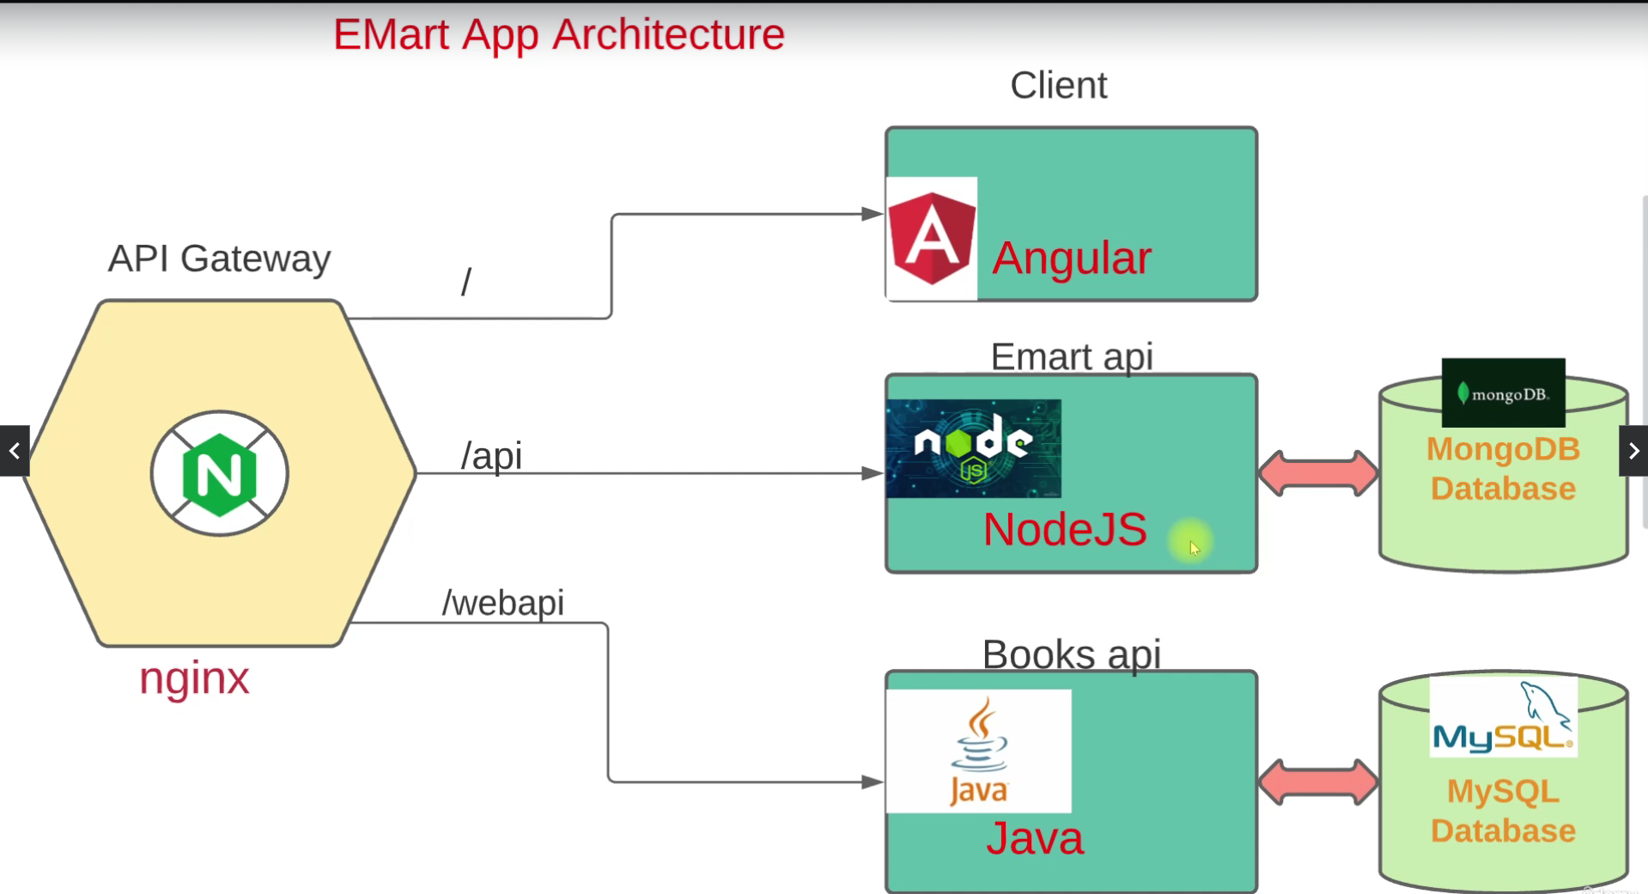

# Bash scripting

<https://visualpath.in/devopstutorials/devops>

#!/bin/bash

###THIS IS MY FIRST SCRIPT###

#System uptime

echo "############################"

echo "system uptime"

echo ""

uptime

echo "############################"

echo "memory utilization"

echo ""

free -m

echo "############################"

echo "Disk utilization"

echo ""

df -h

echo "############################"

#!/bin/bash

sudo apt install apache2 wget unzip -y > /dev/null

sudo systemctl start apache2

sudo systemctl enable apache2

mkdir -p /tmp/webfiles

cd /tmp/webfiles

wget https://github.com/startbootstrap/startbootstrap-business-casual/archive/gh-pages.zip

unzip gh-pages.zip

cp -r startbootstrap-business-casual-gh-pages/* /var/www/html

sudo systemctl restart apache2

rm -rf /tmp/webfiles

sudo systemctl status apache2

ls -l /var/www/html

#!/bin/bash

echo "Printing script name"

echo $0

echo

echo "printing first argument"

echo $1

echo

echo "printing second argument"

echo $2

echo $9

echo $10

**$0 🡪 print the file name or path of the file**

**$1 , $2 ----$n this are command line arguments , which given in the time of execution**

## System variables

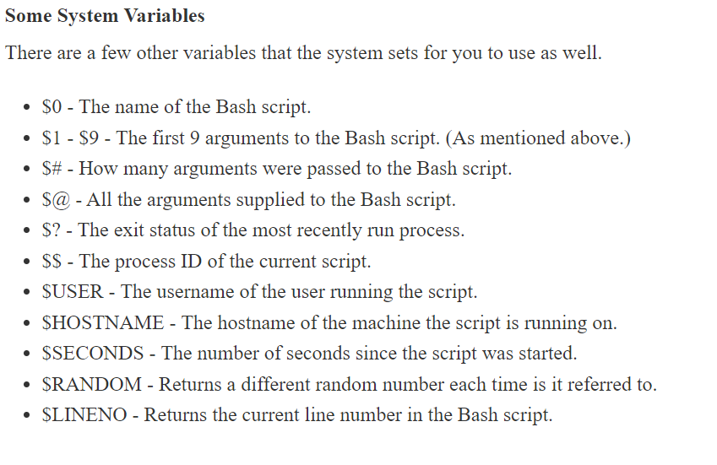

## Quote’s

**Echo “due to the covid 19 most of the company lost \$9 million dollars”**

**:- “\” will be remove special character /features**

## Command substations

#!/bin/bash

echo "Welcome $USER on $HOSTNAME."

echo "#######################################################"

FREERAM=$(free -m | grep Mem | awk '{print $4}')

LOAD=`uptime | awk '{print $9}'`

ROOTFREE=$(df -h | grep '/dev/sda1' | awk '{print $4}')

echo "#######################################################"

echo "Available free RAM is $FREERAM MB"

echo "#######################################################"

echo "Current Load Average $LOAD"

echo "#######################################################"

echo "Free ROOT partiotion size is $ROOTFREE"

## exporting variables

normally export variable is exporting variable global but it is not permanent.(export SEASON)

To make it permanent the edit the **.bashrc** file place the export command they(but it working on particular user , to work in globally the

**vim /etc/profile** 🡪add:- export season =”mansoon”

## user input

#!/bin/bash

echo "Enter your skills:"

read SKILL

echo "Your $SKILL skill is in high Demand in the IT Industry."

read -p 'Username: ' USR

read -sp 'Password: ' pass

echo

echo "Login Successfull: Welcome USER $USR,"

## decision making

### if statement

#!/bin/bash

read -p "Enter a number: " NUM

echo

if [ $NUM -gt 100 ]

then

echo "We have entered in IF block."

sleep 3

echo "Your Number is greater than 100"

echo

date

fi

echo "Script execution completed successfully."

### If -else statement

#!/bin/bash

read -p "Enter a number: " NUM

echo

if [ $NUM -gt 100 ]

then

echo "We have entered in IF block."

sleep 3

echo "Your Number is greater than 100"

echo

date

else

echo "You have entered number less than 100."

fi

echo "Script execution completed successfully."

### Elif statement

#!/bin/bash

value=$(ip addr show | grep -v LOOPBACK | grep -ic mtu)

if [ $value -eq 1 ]

**then**

echo "1 Active Network Interface found."

elif [ $value -gt 1 ]

**then**

echo "Found Multiple active Interface."

else

echo "No Active interface found."

Fi

## Monitoring script

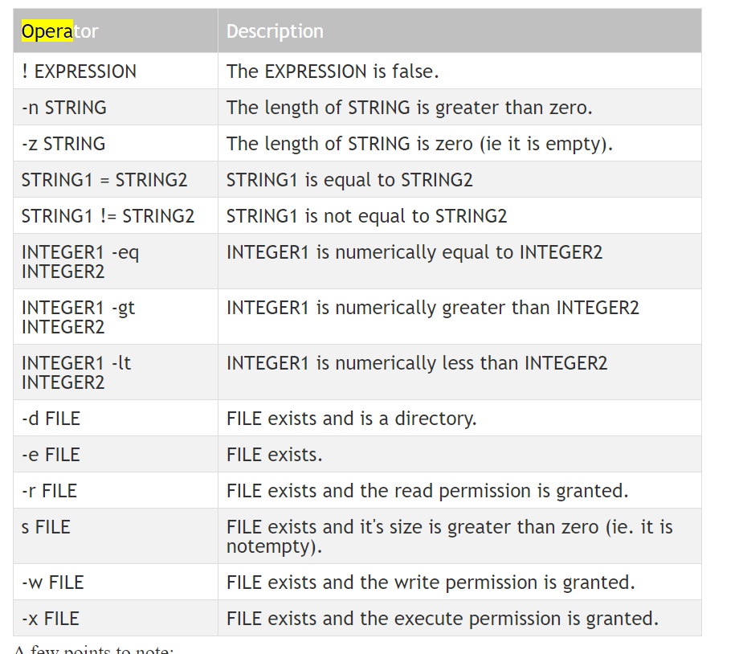

#!/bin/bash

echo "#####################################################"

date

ls /var/run/httpd/httpd.pid &> /dev/null

if [ $? -eq 0 ]

then

echo "Httpd process is running."

else

echo "Httpd process is NOT Running."

echo "Starting the process"

systemctl start httpd

if [ $? -eq 0 ]

then

echo "Process started successfully."

else

echo "Process Starting Failed, contact the admin."

fi

fi

echo "#####################################################"

echo

### crontab

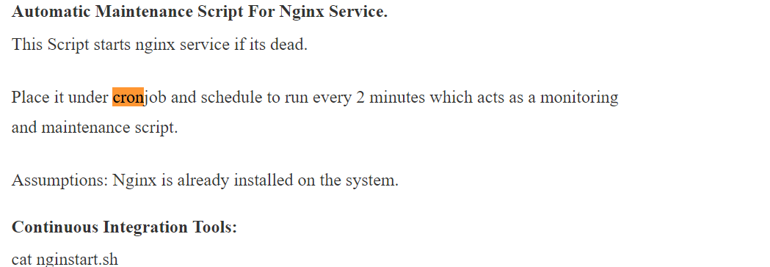

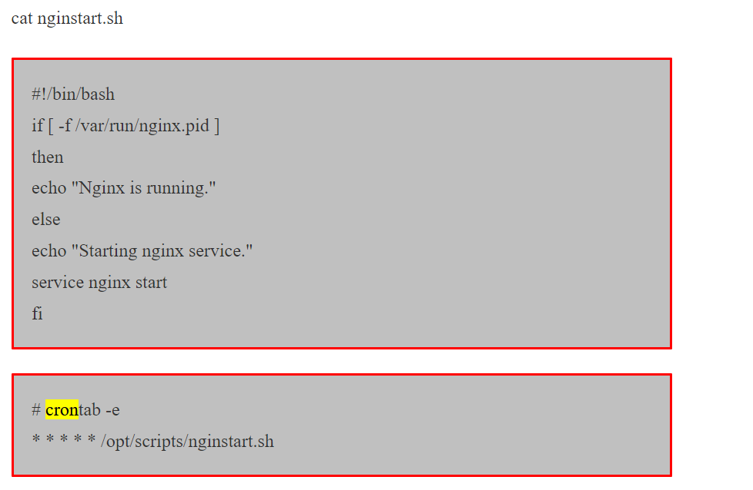

## LOOPS

### For loop

#!/bin/bash

for VAR1 in java .net python ruby php

do

echo "Looping....."

sleep 1

echo "###################################################"

echo "Value of VAR1 is $VAR1."

echo "###################################################"

date

echo

done

### while loop

#!/bin/bash

counter=0

while [ $counter -lt 5 ]

do

echo "Looping...."

echo "Value of counter is $counter."

counter=$(( $counter + 1 ))

sleep 1

done

echo "Out of the loop"

## remote command execution

bring the three vm ‘s in script -vms and set the host names

vim /etc/host 🡪 web01 (host-name)

hostname web01

set all the three vms

🡪go to /etc/hosts 🡪 add the ip address : hostname

192:168:56:11 web01

192:168:56:12 web02

192:168:56:13 web03

Then try to ping in the user

Ping web01🡪check

Ping web02 🡪check

Ping web03 🡪 check

Ssh vagrant@web01 🡪 set the password(give the password)

Create a new user

🡪useradd devops

* Passwd devops

Visudo 🡪 add user devops 🡪 nopasswd : ALL

Do same for web02 also

Do same for web03 also 🡪 web03 ubuntu don’t allow to password login so we need to give key

Vim /etc/ssh/sshd_config 🡪 passwordauthicated yes (so we can use password now)

* **Ssh vagrant@web03 uptime 🡪 we give password and execute the command here itself**

**But we can avoid the password login everytime using key base**

## SSH KEY EXCHANGE

Ssh-keygen 🡪 to generate the key

We can key lock to the user by keep the key 🡪 **ssh-copy-id devops@web01 (do for all web02 , web03)**

**So that it won’t ask password again , using public and private key’s**

**remhost**

**web01**

**web02**

**web03**

**for host in `cat remhost`; do ssh devops@host sudo yum install git -y; done**

* **Check multivms script in devops learning.**

# QUESTION

Continuous Integration (CI)?

Continuous Integration (CI) is a software development practice where developers regularly merge their code changes into a shared repository. Automated tests quickly check for errors, providing prompt feedback to detect and fix issues early in the development process. The goal is to maintain a consistently stable and functional codebase, enabling faster and more reliable software development.

Continuous Delivery (CD)?

Continuous Delivery (CD) is a software development approach automating the process of reliably and quickly delivering code changes to production or staging environments. It involves automated deployment, rigorous testing, and incremental releases, ensuring high-quality software can be released at any time with confidence.